Theme | Community - City-Wide Project
Project | Londonderry Citizens Advice Bureau - Core Salaries & Running Costs
Aim | The project provides advice and information, advocacy and court representation on Social Welfare Benefits, consumer Law, Employment Law, Housing, Legal issues, Debt and Tax to over 8,000 individuals and families in Derry;  Provision also such as representation to a number of clients at welfare law appeal tribunals eg DLA and ESA appeals;  Project also offers advice and information via telephone, face to face contact, e-mail, home-visitation, outreach , and internet which is impartial, confidential independent and free of charge
Activities | The Citizens Advice Bureau provides a service that is impartial, confidential, independent and free to all individuals to ensure they do not suffer through ignorance of their rights and responsibilities or suffer through an inability to express their needs effectively.
Link to NR Action Plan | Cityside NR Action Plan:  - Community Renewal  - Social Renewal  - Economic Renewal  Waterside NR Action Plan:  - Community Renewal  - Social Renewal  - Economic Renewal  Outer West NR Action Plan:  - Community Renewal  - Social Renewal  - Economic Renewal  Outer North NR Action Plan:  - Community Renewal  - Social Renewal  - Economic Renewal
Output | To deliver services including advice, information, advocacy and court representation on issues, such as, Social Welfare Benefits, Consumer Law, Employment Law, Housing, Legal Issues, Tax etc all of which assist in reducing poverty and social need across the City which will facilitate the achievement of the strategic objectives of Neighbourhood Renewal.
Outcome | Through this project ‘advice and information services’ this assists to reduce poverty and assist people to know their rights . The project delivers a full package of advice services to the citizens of Derry to enable CAB to promote self help, advocacy, empowerment and personal development of individuals who in turn can actively participate within their local communities. CAB are committed to improve social conditions for people who live in the most deprived neighbourhoods throughout the NR areas and beyond through providing a co-ordinated advice service on the many issues.
Link to NR Strategy | Community Renewal  Increase in community capacity  Increase in the percentage of residents involved in volunteering activities  Social Renewal  Increase in overall life expectancy (through targeting people suffering from poverty and ensuring they are aware of Benefit entitlements / Welfare Reform issues etc)
Link to One Plan | Transformational Themes:  Building Better Communities  Education & Skills  Employment & Economy
Photos | 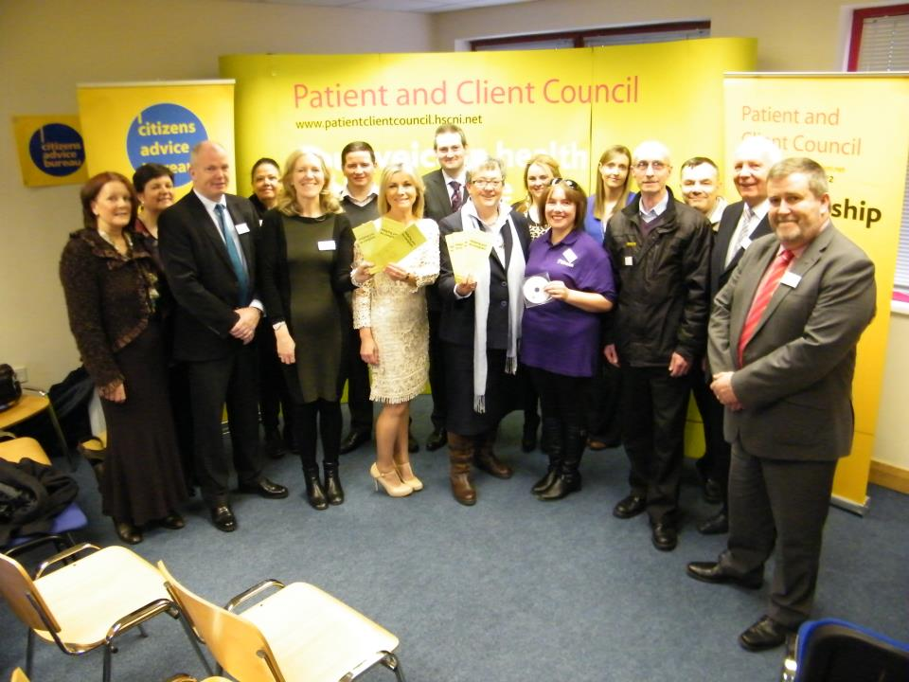  Patient and Client Council Promotion. CAB staff member giving advice and  guidance to two customers.
SM/NPB Comments | Citizens Advice Bureau (CAB) is a very well established organisation and brand who deliver considerable amount of services and programmes across the entire city and district. Numerous residents from the four Neighbourhood Renewal Areas avail of their services on a daily basis.  The current economic climate, the rising number of people unemployed, the impending attack on those on benefits dressed up as Welfare Reform and increasing levels of personal debt have put massive strain on communities and residents living in Neighbourhood Renewal Areas and it is these issues that CAB are tackling and having a direct impact on the delivery of the Triax Neighbourhood Action Plan.  This CAB projects assists in delivering the Triax priority action:  - Help to eradicate poverty by providing welfare/ welfare-to-work, debt advice to maximise income and connect socially excluded residents to neighbourhood services. (NINIS and community consultation).
Contact Details | Jackie Gallagher – Londonderry Citizens Advice Bureau Manager  Tel: 02871 272991  Email: jackiegallagher42@btinternet.com

Theme | Community - City-Wide Project
Project | An Gaelaras - The Fleadh 2013
Aim | This project has appointed a Manager and two part time Neighbourhood IT Coordinators for Fleadh Cheoil na hÉireann 2013 – these staff are currently assisting in managing and identifying the many opportunities for the residents of the four NR Areas resulting from this famous event. The Festival will engage and ensure maximum benefit to local neighbourhood renewal areas targeting at least 80% of these residents. Fleadh Cheoil na hÉireann is a ten-day long event open to all, embracing all aspects of the Irish Cultural traditions, music, song, dance and an Ghaeilge. It is the world’s largest celebration of traditional Irish culture. While competition is an important element of the Fleadh, the event is a multi-faceted shop window for Irish culture. It is estimated that the event will be attended by in the region of 300,000 people and generate an estimated income of upwards on €40 million in Derry and its hinterland.
Activities | Activities include - promotion and celebrate of traditional arts and opportunities in Derry; To involve local NR neighbourhoods to ensure maximum educational, social, training, employment and economic benefit; To host an environmentally-friendly Fleadh; To host a disability-friendly Fleadh; To host an inclusive cross–community Fleadh; To promote Derry as a tourism, business and shopping destination  To build strategic partnerships and promote civic unity; To contribute to the building of peace and reconciliation; To leave a legacy of traditional music and cultural awareness.
Link to NR Action Plan | Cityside NR Action Plan:  - Community Renewal  - Social Renewal  - Economic Renewal  Waterside NR Action Plan:  - Community Renewal  - Social Renewal  - Economic Renewal  Outer West NR Action Plan:  - Community Renewal  - Social Renewal  - Economic Renewal  Outer North NR Action Plan:  - Community Renewal  - Social Renewal  - Economic Renewal
Output | Manager and 2 x part time Development Workers positions in place to manage and co-ordinate all aspects of the Fleadh. Businesses will be advised of the opportunities arising from the Fleadh. Opportunities created for residents to start new businesses in this sector e.g. B&B, Tour Guides; work with local business owners to enhance shop fronts; contribute positively to small business forum & social enterprise hub.
Outcome | Fleadh Cheoil na hÉireann depends largely on volunteers. The event will require 2,000 approx’ volunteers to ensure its success in the city. Training will include stewarding, customer service, tourism as well as music tuition in a variety of instruments. Project will build on the work of the Extended Schools Clusters and create opportunities to ensure that children and young people’s issues, ideas, views and opinions are listened to and taken into account. Fleadh Cheoil na hÉireann aims to target as many as possible of the school population of Derry with information and opportunities.
Link to NR Strategy | Community Renewal -  Increase in community capacity/capital/cohesion?  Increase in the percentage of residents involved in volunteering activities  Improvement in community relations  Economic Renewal/  Increase in number of employee jobs  Reduction in the gap in employment rate  Reduction in percentage of population economically inactive  Increase in participants on Small Business Support Programme  Number of pupils benefiting from projects designed to improve attainment  Social Renewal  Crime and Anti-Social Behaviour  Reduction in anti-social behaviour incidents
Link to One Plan | Transformational Themes:  Building Better Communities  Education & Skills  Employment & Economy  Health & Well Being
Photos | 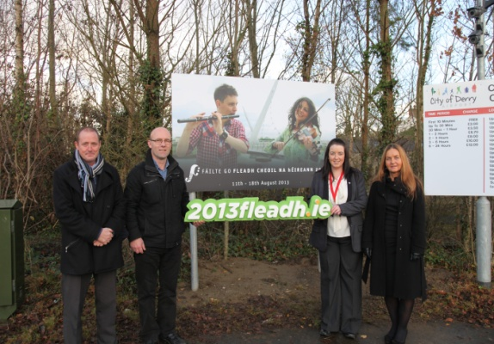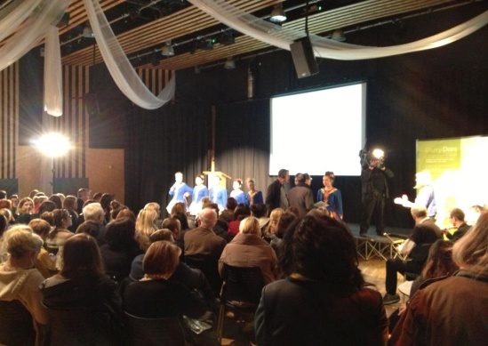  Photo on left- One of bilingual information signs erected at the City Airport to  Promote tourism product.  Photo on Right- Volunteer recruitment drive, December 2012.
SM/NPB Comments | Measurable impacts of the project have yet to be seen however opportunities and benefits to the local communities and impacts on the NAP’s should be significant with an 80% NRA resident beneficiary target. Triax are confident that the Fleadh will have a significant impact in this area as much of its activities are located here. We have had significant contact and engagement with the Fleadh to date. This projects will assist in delivering the Triax priority action:  - Lack of co-ordinated strategy to promote heritage/cultural community tourist initiatives in the Triax area.
Contact Details | Donncha MacNiallais - Fleadh Cheoil Na hEireann 2013  Tel: 02871 264132  Email – Donncha@culturelann-doire.ie
Theme | Community - City-Wide Project
Project | St Columb’s Cathedral - Tourist Guides Initiative
Aim | This project provides a tourist guide service to promote St Columb’s Cathedral as one of the most historic and cultural landmarks in the City which attracts local, regional and international visitors throughout the year and also offers a cultural and educational facility to schools. St Columb’s Cathedral Tourist Guides Initiative employs one full time and two part time Tourist Guides. St Columb’s Cathedral – Tourist Guide Initiative project provides a service to the local community and visitors to the City through the provision of informative tours on the educational, historical and cultural attributes of St Columb’s Cathedral, one of the most historical buildings in the City.
Activities | Tourist Guides within St Columb’s Cathedral are employed to provide the following activities – A Tourist Guides Initiative to local school children, residents and tourists/visitors to the City. To be informative and historical in promoting St Columb’s Cathedral to this audience by providing a comprehensive package of tour guides to local school children and visitors to the City to promote the historic, cultural and educational aspect of one of the most prestigious buildings in the City. To promote the regeneration of the City as per DSD ‘s NR Strategy and Heart of the City Strategy.
Link to NR Action Plan | Cityside NR Action Plan:  - Community Renewal & Social Renewal  Waterside NR Action Plan:  - Community Renewal  - Social Renewal  Outer West NR Action Plan:  - Community Renewal  - Social Renewal  Outer North NR Action Plan:  - Community Renewal  - Social Renewal
Output | This Tourist Guides Initiative enables this valuable service to promote the Cathedral as a historical landmark in the City attracting local, regional and international visitors to the Cathedral and the City as a whole as well as providing educational and cultural opportunities for local schools and communities. and assists in delivering the Neighbourhood Action Priorities identified within the Action Plans across the City.
Outcome | This Tourist Guide Initiative provides educational and cultural opportunities for local schools and communities and assists in delivering against the identified Neighbourhood Action Priorities identified within the Action Plans across the City. Up to 80,000 visitors, many from other countries visit this site throughout the year which also encourages financial / economic investment into the City..
Link to NR Strategy | Community Renewal  Increase in community capacity/capital/cohesion?  Improvement in community relations
Link to One Plan | Transformational Themes:  Building Better Communities  Education & Skills  Employment & Economy
Photos | 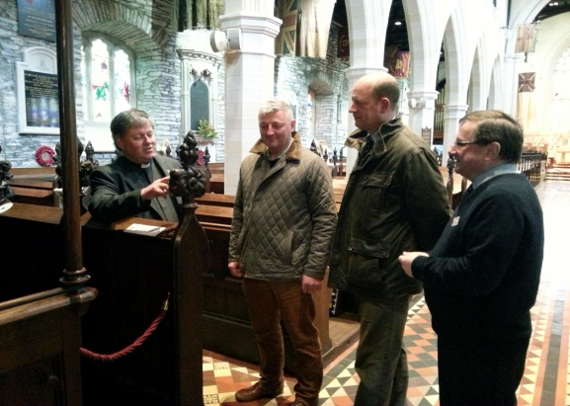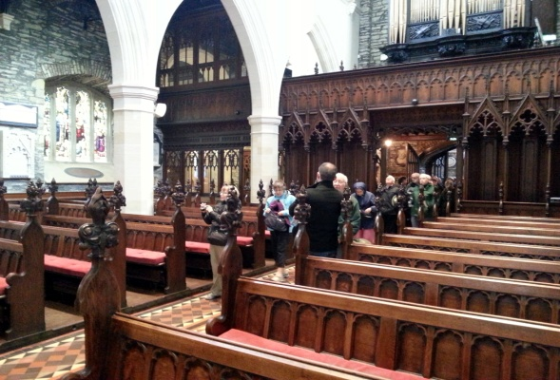  1.The Dean of Derry The Very Rev Dean Morton with Ian Bartlett the Cathedral Tour Guide with members from the national Trust.  2. A group of Canadian Tourists on a guided tour of the Cathedral.
SM/NPB Comments | The Tourist Guides Initiative is an important project for the city and the Triax area as it is part of the tourist product that we are promoting. Heritage and Cultural Tourism is a priority action within the Triax Neighbourhood Action Plan and this project is integral to delivery of these actions.  As this is a Citywide project we have limited interaction with the project but do see it as a worthwhile contribution to the City.  This projects will assist in delivering the Triax priority action:  - Lack of co-ordinated strategy to promote heritage/cultural community tourist initiatives in the Triax area.
Contact Details | Robert McGonigle – St Columbs Cathedral  Tel: 07794666754  E- Mail – robertmac2011@gmail.com

Theme | Community- City-Wide Project
Project | Shantallow Community Residents Association* - Youth Educated in Safety
Aim | The main aims and objectives of the project is to provide an Interactive Health & Safety related educational experience to all Yr 6 and Yr 7 pupils across all 4 Derry NR areas. It will also serve post primary school children, community groups, youth organisations, at risk young people and other vulnerable groups.
Activities | To provide young people with interactive workshops on health and safety issues and personal development programmes based on physical and mental health as well as personal safety and community safety issues. These workshops and programmes include drug, alcohol and substance awareness, sexual awareness, anti bullying, cultural and community relations, mediation and conflict resolution, building intergenerational relationships, hoax calls/attacks on emergency services, and activities include environmental improvements, such as, alternatives to bonfires and community murals and health and fitness initiatives, such as, inclusive games, yoga, midnight street soccer etc. The project will actively assist in educating young children from the 4 NRA’s in health and safety issues affecting their communities and the initiatives and workshops will assist in improving social conditions across all 4 NRA’s and impact on the delivery of Action Plans across all 4 areas
Link to NR Action Plan | Outer North NR Action Plan:  - Social Renewal  Outer West Action Plan:  - Social Renewal  Cityside NR Action Plan:  - Community Renewal & Social Renewal  Waterside NR Action Plan:  - Social Renewal
Output | To form key partnerships with the local schools, statutory agencies and community organisations in lobbying for the need to provide services for school children to actively deliver a health and safety initiative dealing with real problems and issues effecting these children and the areas they live in so that they may understand the dangers of anti-social activities, bullying, drug and alcohol abuse, attacks on public services etc and the consequences of these actions particularly in areas of multi deprivation.  - To reduce the number of attacks on emergency services and to reduce the demand on services in terms of repair bills and dealing with false alarms.  - To improve the relationships between existing agencies and the community.  - To improve the knowledge base and understanding of young people & to provide people with the skills necessary to recognise and deal with potential hazards.  - To provide information which will allow local people to make informed lifestyle choices.
Outcome | Community Renewal  - To increase the proportion of residents in the most derived neighbourhoods involved in community activities  - To increase the proportion of residents giving a positive assessment of community sector activities  Social Renewal  - To reduce the overall crime rates in the most deprived wards to the Northern Ireland rate  - To halve residents reported perceptions of the levels of crime and anti-social behaviour in their area  - To increase residents reported level of security
Link to NR Strategy | Community Renewal -  Increase in the percentage of residents involved in volunteering activities  Improvement in community relations  Economic Renewal/  Number of pupils benefiting from projects designed to improve attainment  Social Renewal  Crime and Anti-Social Behaviour  Reduction in anti-social behaviour incidents
Link to One Plan | Transformational Themes:  Building Better Communities  Health & Well Being
Photos | 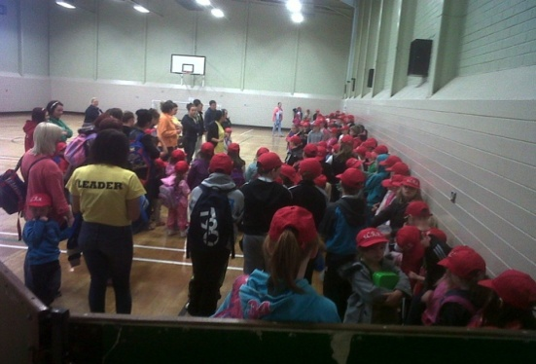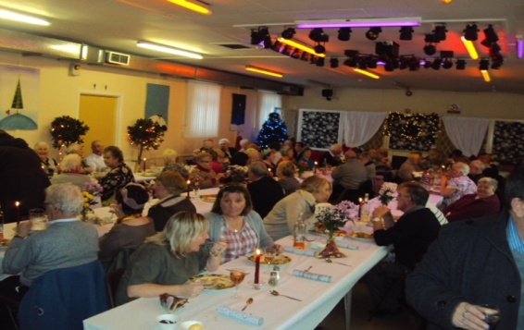
MSM/NPB Comments | The project is coordinating and delivering workshops, multi-agency events and programmes across the 4 city NRAs, implemented primarily through local Primary schools and connecting to a range of service providers. It is building awareness, skills and knowledge amongst young people and having a particular impact on education, community safety and health related priorities identified in each of the Neighbourhood Action Plans.  One of the issues affecting the Triax area is anti-social behaviour particularly at times of high tension in this interface area, as well as crime, graffiti, underage drinking, attacks on ambulance and PSNI etc. This project has delivered in the local Triax schools in partnership with our own community groups and has assisted to educate young people to address ownership for their areas through this workshop and is in line with priorities in our Action Plan, such as:  - Community safety and fear of crime including anti-community activity, risk taking behaviours, sectarian clashes and nuisance behaviour.  - To improve the local environment in terms of physical environment ie graffiti, litter and biodiversity ie green spaces, planting, priority species.
Contact Details | Cathal McCauley - SCRA  Tel: 028 7128 0250  Email@ shantallow123@btconnect.com
Theme | Physical
Project | DRD Roads Service: Northern Division - Upgrading of Footways & Lighting at Rossville Street, Derry
Aim | To provide 3,100 m2 of resurfaced carriageway and new footway surface in high quality finishes and upgrading of street lighting at Rossville Street for much needed improvements to provide safer streets for all pedestrians and to enhance the physical appearance of a major access to the city centre.
Activities | 3,100 m2 of resurfaced carriageway, new footway surface in high quality finishes and upgrading of street lighting at Rossville Street.
Link to NR Action Plan | Cityside NR Action Plan:  - Community Renewal & Physical Renewal
Output | The scheme aimed to improve the image of this community enhancing the environment in terms of appearance and pedestrian safety for the benefit of residents living within this disadvantaged area and the outcome was to enhance the physical environment, making links within the city more attractive.
Outcome | The completed project of 3,100 m2 of carriageways, high quality footways and street lighting has been implemented and has physically enhanced the Rossville Street area and has helped create an attractive, safe and sustainable environments in this deprived neighbourhood. The project has attained a high quality upgrade of the Rossville Street area in and around the commercial core of the city. The project also compliments other interventions taking place to prepare the city for the City of Culture 2013 to deliver investment in infrastructure for the delivery for the City of Culture 2013 events.
Link to NR Strategy | Physical Renewal:  Increased satisfaction levels with local environment
Link to One Plan | Transformational Themes:  Building Better Communities
Photos | Rossville Street – Before Scheme: Rossville Street – After Scheme:  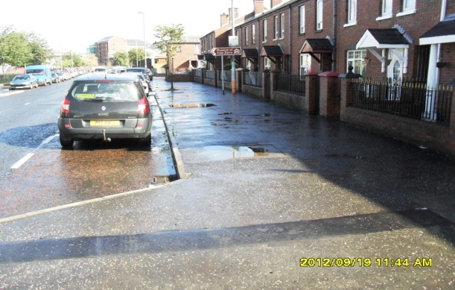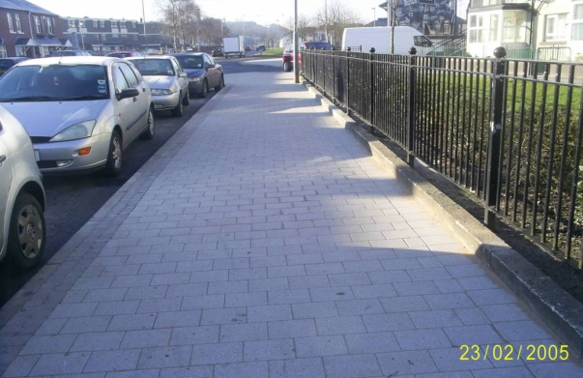
SM/NPB Comments | Rossville Street attracts thousands of tourists and visitors every years and this area had been identified by Triax Culture and Tourism Sub Group as a priority for Environmental Improvement. This project compliments other local initiatives by the Tourism and Culture Sub Group who are implementing Towards A Community ourism Strategy For Triax.  While this work is welcome as it compliments the tourism product in the area, it enhances the area in advance of the City of Culture events that will take place but more importantly it enhances and improves the area for the residents who live there.  This projects assisted in delivering the Triax NAP priority:-  - How an area looks and how it os designed to can be a major contributing factor to it feeling unsafe.  - Lack of co-ordinated strategy to promote heritage/ cultural community tourist initiatives in the Triax area.
Contact Details | Adrian Doherty – DRD Roads Service: Northern Division  Tel: 64658  Email: adrian.doherty@drdni.gov.uk

Theme | Physical - City-Wide Project
Project | DRD Roads Service: Northern Division - Upgrading of Street Lighting on the Foyle Embankment – Phase 2
Aim | The aim of this project is to upgrade the street lighting in the area from Water Street, along the Foyle embankment from Water Street to the Foyleside roundabout which will tie into the existing lighting on Foyle Road, Foyle Street and John Street.  The project will provide safer streets for all road users and pedestrians and enhance the physical daytime and night time appearance of a major approach to the city.
Activities | General enhancement of street lighting system by erecting 96 no high specification street lighting units with all the necessary 60/140 watt cosmopolis (white light) lanterns
Link to NR Action Plan | Social Renewal – to improve public services and create safer environments  Physical Renewal – to help create safe, attractive sustainable environments
Output | E10 Walkways improved
Outcome | To have contributed to DSD regeneration objective of creating vital and viable towns and cities throughout Northern Ireland  Increased satisfaction levels with local environment.
Link to NR Strategy | Physical Renewal – positive impact both day and night to the general appearance of the streets  Social Renewal – increase in levels of safety due to increased street lighting
Link to One Plan | Improvement in street lighting linking Fort George, the Peace Bridge and Ebrington.
Photos | To insert
SM/NPB Comments
Contact Details | Ken Whiteside DRD Roads Service Northern Division, County Hall, Coleraine

