Theme | Community
Project | Dove House Community Trust – Youth Co-ordinator
Aim | Youth First is an innovative Youth Provider located within the Triax Neighbourhood Renewal Area. Youth First is concerned with all aspects of the development of children and young people, which is reflected in the programmes it provides. The type of current activities provided by Youth First includes programmes which address the educational, physical, social, emotional and personal developmental needs of our young people (and their families), each of whom reside in an area which continues to be characterised with social and economic deprivation.
Activities | Include:  Provision of a Youth Facility  Youth First – Youth Facility providing Youth Initiatives & Diversionary Projects  Provision of Interface Projects  Cross Community Projects  U-turn Project for drugs and anti-social behaviour  Drug & Alcohol Awareness Programmes  Family Fun Days and Initiatives  Community Clean Ups
Link to NR Action Plan | Cityside NR Action Plan:  - Community Renewal & Social Renewal  - Community Renewal & Physical Renewal
Output | To provide a Youth Facility offering programmes and initiatives to address local issues, provide community intervention initiatives in this interface community and to develop youth to their full potential to assist in improving the quality of life for residents living in the Triax Neighbourhood Renewal Area.
Outcome | A youth facility is available and local youth have accessed an extensive range of youth programmes, including the youth club, dance classes, parents advisory group, drama classes, winter intervention programmes, health programmes, volunteering opportunities, U-turn project for youth affected with behaviour issues, drug and alcohol awareness projects, intervention programmes at times of high tension, cross community projects, interface projects, Music Promise etc all of which have provided activities to deter anti-social behaviour and to provide positive opportunities which has made this area a better place to live.
Link to NR Strategy | Community Renewal  Increase in community cohesion/capacity  Increase in the percentage of residents involved in volunteering activities  Improvement in community relations  Crime & Anti-social Behaviour  Reduction in overall recorded crime rate  Reduction in violent crime rate  Reduction in burglary crime rate  Reduction in theft crime rate  Reduction in anti-social behaviour incidents
Link to One Plan | Transformational Themes:  Building Better Communities  Health & Well Being  Education & Skills
Photos | Family Fun Day: U-turn Project:  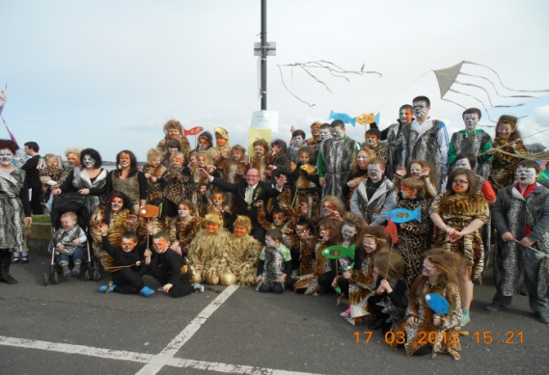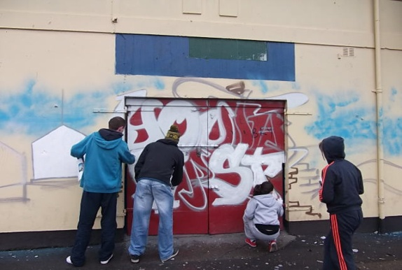
SM/NPB Comments | Triax has a very vibrant youth sector who preform an enormous amount of challenging and at times ground-breaking work. Many of the issues that our youth workers deal with are often under the radar and at times get very little recognition. Youthfirst, Cathedral YC and Creggan Youth Drop In are all members of The Triax Youth Subgroup which is often mentioned as a Model of Best Practice by WELB and others.  Dove House Youth Co-ordinator enables Triax to delivers on the NAP as they work with various community partners to tackle a number of identified needs, such as;  - Community safety and fear of crime including Anti-community activity, risk taking behaviours, sectarian clashes and nuisance behaviour.  - How an area looks and how it is designed can be a major contributing factor to it feeling unsafe.  - Barriers to employment, lack of skills and qualifications needed for employment has been a major issues in this community for decades.  - Health Inequalities and poor health have been a fact of life in this and other working class deprived communities for decades.
Contact Details | Bronach McMonagle – Manager  Tel: 02871 273976  Email: bronach@dovehousecommunitytrust.com

Theme | Community
Project | Creggan Neighbourhood Partnership – Youth Intervention Co-ordinator
Aim | The CNP Youth Intervention Project delivers a dedicated youth project within the Creggan area delivering youth programmes and intervention services and a drop-in facility. The project encourages young people to develop personally, socially and academically with the aim of guiding these youth away from anti-social behaviour towards entering the labour market and developing themselves as individuals in a constructive and positive way.
Activities | Include:  Provision of a Youth Facility; Youth Facility providing Youth Initiatives & Diversionary Projects; Drug & Alcohol Awareness Programmes; Sexual Awareness Programmes; Youth Fun Days and Initiatives; Cross Community Projects; Youth Development for individual Youth involved in anti-social activities; Training Programmes; Community Clean Ups.
Link to NR Action Plan | Cityside NR Action Plan:  - Community Renewal & Social Renewal  - Social Renewal  - Community Renewal & Physical Renewal
Output | To provide a Youth Facility offering programmes and initiatives to address local issues, provide community intervention initiatives, training programmes, awareness programmes, positive youth programmes for those involved in anti-social activities and to develop youth to their full potential to assist in improving the quality of life for residents living in the Triax Neighbourhood Renewal Area.
Outcome | A youth facility is available and local youth have accessed a range of youth programmes, including the youth club, Drug & Alcohol Awareness Programmes, Sexual Awareness Programmes, Youth Fun Days and Initiatives, Cross Community Projects, Youth Development for individual Youth involved in anti-social activities, Training Programmes, Community Clean Ups and City of Culture Events etc all of which have provided activities to deter anti-social behaviour and to provide positive opportunities which has made this area a better place to live.
Link to NR Strategy | Community Renewal  Increase in community cohesion/capacity  Increase in the percentage of residents involved in volunteering activities  Improvement in community relations  Economic Renewal/Worklessness  Number of pupils benefiting from projects designed to improve attainment (primary)  Number of pupils benefiting from projects designed to improve attainment (secondary)  Crime & Anti-social behaviour  Reduction in overall recorded crime rate  Reduction in violent crime rate  Reduction in burglary crime rate  Reduction in theft crime rate  Reduction in anti-social behaviour incident
Link to One Plan | Transformational Themes:  Building Better Communities  Health & Well Being  Education & Skills
Photos | Youth Football Barton Cup: Youth involved in Operation Snowball: 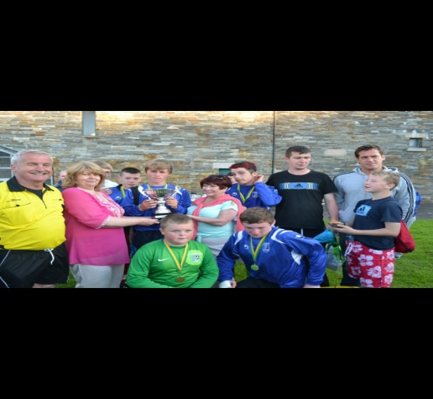 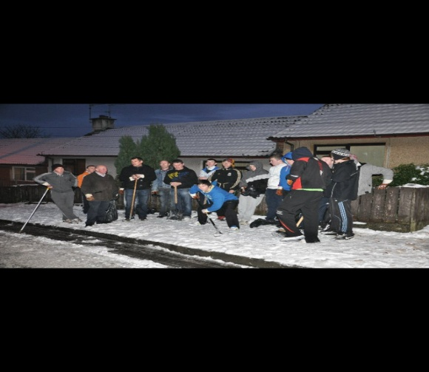
SM/NPB Comments | Triax has a very vibrant youth sector who perform an enormous amount of challenging and at times ground-breaking work. Many of the issues that our youth workers deal with are often under the radar and at times get very little recognition. Youthfirst, Cathedral YC and Creggan Youth Drop In are all members of The Triax Youth Subgroup which is often mentioned as a Model of Best Practice by WELB and others. Creggan Youth Drop enables Triax to deliver on the NAP as they work with various community partners to tackle a number of identified needs and priorities, such as;  - Community safety and fear of crime including Anti-community activity, risk taking behaviours, sectarian clashes and nuisance behaviour.  - How an area looks and how it is designed can be a major contributing factor to it feeling unsafe.  - Barriers to employment, lack of skills and qualifications needed for employment has been a major issues in this community for decades.  - Health Inequalities and poor health have been a fact of life in this and other working class deprived communities for decades.
Contact Details | Shauna Derry – Project Co-ordinator  Tel: 02871 281900  Email: shaunadeery@hotmail.com

Theme | Community
Project | Cathedral Youth Club – Youth Worker
Aim | The aim of the Cathedral Youth Club – Youth Project is to provide a dedicated youth service providing positive projects and programmes dealing with issues in the community and interface, engage young people in positive activities thus reducing the level of anti-social behaviour, encourage young adults to work closely with PSNI, PRG, local councillors and MLA’s to address issues around anti-social behaviour and interface violence, provide a forum to develop and deliver cross community activities, promote the development of personal and social skills to achieve higher levels of education and employment and to assist young adults in job search and interview skills. The project addresses community safety, health and well being, education and skills and employment & economy within the Cityside Action Plan.
Activities | Include:  Provision of a Youth Facility; Youth First – Youth Facility providing Youth Initiatives & Diversionary Projects; Provision of Interface Projects; Cross Community Projects; Drug & Alcohol Awareness Programmes  Family Fun Days and Initiatives; Community Clean Ups; Growing Together Initiative; Culture Drumming Workshops; City of Culture Workshops  Advice and assistance for job search activities; Healthy Living Initiative; Young Enterprise Company Programme
Link to NR Action Plan | Cityside NR Action Plan:  - Community Renewal & Social Renewal  - Economic Renewal  - Community Renewal & Physical Renewal
Output | To provide a Youth Facility offering programmes and initiatives to address local issues, provide community intervention initiatives in this interface community and to develop youth to their full potential to assist in improving the quality of life for residents living in the Triax Neighbourhood Renewal Area.
Outcome | A youth facility is available and local youth have accessed an extensive range of youth programmes, including the youth club, dance classes, , drama classes, health programmes, volunteering opportunities, drug and alcohol awareness projects, intervention programmes at times of high tension, cross community projects, interface projects, training, job club, crime awareness workshops, Music Promise etc all of which have provided activities to deter anti-social behaviour and to provide positive opportunities to make this area a better place to live.
Link to NR Strategy | Community Renewal  Increase in community cohesion/capacity  Increase in the percentage of residents involved in volunteering activities  Improvement in community relations  Social Renewal:  Crime & Anti-social behaviour  Reduction in overall recorded crime rate  Reduction in violent crime rate  Reduction in burglary crime rate  Reduction in theft crime rate  Reduction in anti-social behaviour incidents  Health  Increase in overall life expectancy  Economic Renewal  Reduction in percentage of population economically inactive
Link to One Plan | Transformational Themes:  Building Better Communities  Health & Well Being  Employment & Economy
Photos | Catherdal Youth Club Facility : Youth Drumming Band :  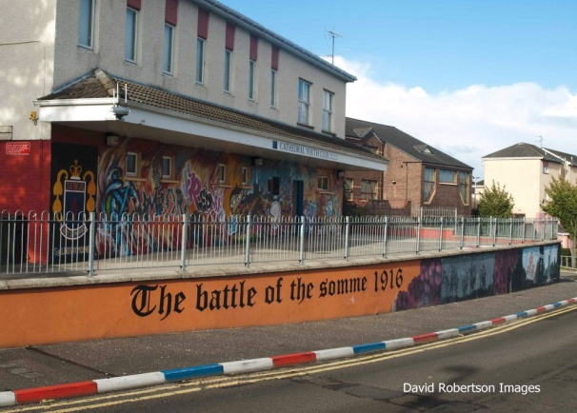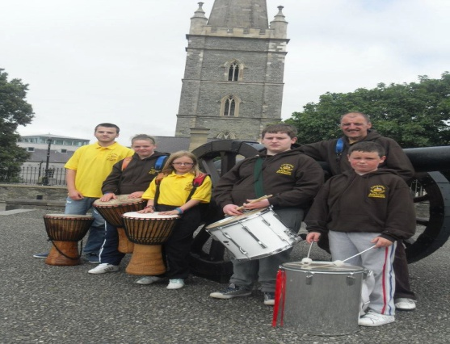
SM/NPB Comments | Triax has a very vibrant youth sector who perform an enormous amount of challenging and at times ground-breaking work. Many of the issues that our youth workers deal with are often under the radar and at times get very little recognition. Youthfirst, Cathedral YC and Creggan Youth Drop In are all members of The Triax Youth Subgroup which is often mentioned as a Model of Best Practice by WELB and others. Cathedral YC enables Triax to delivers on the NAP as they work with various community partners to tackle a number of identified needs and priorities, such as;  - Community safety and fear of crime including Anti-community activity, risk taking behaviours, sectarian clashes and nuisance behaviour.  - How an area looks and how it is designed can be a major contributing factor to it feeling unsafe.  - Barriers to employment, lack of skills and qualifications needed for employment has been a major issues in this community for decades.  - Health Inequalities and poor health have been a fact of life in this and other working class deprived communities for decades.
Contact Details | Jeanette Warke – Manager  Tel: 02871 260483  Email: jeanettewarke@hotmail.co.uk

Theme | Community - City-Wide Project
Project | Greater Shantallow Area Partnership – Community Engagement Project
Aim | This project is focused on the provision of a Citywide Community Engagement Team to maximise participation in City of Culture programme activities, increase community capacity through encouraging participation and volunteering opportunities, enhance the employability of residents, increase the number of community, arts and cultural events and activities being developed and delivered within NRA’s, support with accessing funding sources, and to develop a framework of local delivery structures within the NRA’s for future programme delivery. The project will focus on community participation leading to improved social and economic benefits across the 4 NRA’s of the City.
Activities | Include:  A Support Structure in place for each of the 4 NRA’s  Maximising community awareness  Increasing community participation and engagement  Sourcing funding streams  Develop arts culture and community activities
Link to NR Action Plan | Cityside NR Action Plan:  - Economic Renewal & Social Renewal  - Community Renewal & Social Renewal  Outer North NR Action Plan:  - Community Renewal  Outer West NR Action Plan:  - Community Renewal  Waterside NR Action Plan:  - Community Renewal
Output | To provide a Citywide Community Engagement Team for the 4 NRA’s to maximise and increase participation in community activities, to actively support communities with the development and delivery of arts, cultural and community programmes and with accessing funding sources to progress the key NR strategic objective of Community Renewal.
Outcome | A Community Engagement Team in place to support each of the 4 NRA’s to maximise community engagement and participation in community and cultural events.
Link to NR Strategy | Community Renewal  Increase in community capacity/capital/cohesion  Increase in the percentage of residents involved in volunteering activities  Improvement in community relations  Economic Renewal Worklessness  Reduction in percentage of population economically inactive  Number of pupils benefiting from projects designed to improve attainment  Social Renewal  Health  Increase in overall life expectancy  Crime and Anti-Social Behaviour  Reduction in anti-social behaviour incidents  Physical Renewal  Increased satisfaction levels with local environment
Link to One Plan | Transformational Themes:  Building Better Communities  Education & Skills  Employment & Economy
Photos | Project only commenced 19 March 2013 ie no photos at this initial stage.
SM/NPB Comments | The project was developed by the 4 Derry NPBs and Culture Company and approved by DSD at the end of February 2013. Recruitment of a Co-ordinator and 4 Community Engagement Officers was undertaken in March 2013 – however the project has hit the ground running and is supporting cultural activities within the 4 NRAs and across the city, with a clear focus on maximising resident participation in a range of programme activities. Foundations have been built to realise significant benefits across social and economic renewal targets, but primarily community renewal priorities identified in the Neighbourhood Action Plans.  As Triax is the largest NRA in the City, it is imperative that we instil the Neighbourhood Renewal process across our community to encourage all residents to take ownership on improving our community capacity to mahe Triax a better place in which to live. The Community Engagement Officer for the Triax NRA will assist with maximising community participation, access funding for cultural and community programmes and increase awareness of the programmes and initiatives that are available to our community in line with priorities in our Action Plan, such as:  - Improve service delivery of providers within Triax as residents have little knowledge of how statutory and other agencies are structured and thus how to go about influencing them.
Contact Details | Darren Kirby – Greater Shantallow Area Partnership  Tel: 02871 358787  Email: darren@shantallow.org

Theme | Community - City-Wide Project
Project | Community Restorative Justice - Neighbourhood Renewal Community Mediation Service
Aim | This project, Community Restorative Justice (Ireland) – NW Region (CRJ) - Neighbourhood Renewal Community Mediation Service is focused on the Community Based Crime Prevention Policy which outlines that the organisation primarily focus on interventions at Level 1 (general needs associated with preventing the risk of crime) and Level 2 (specific needs directly associated with crime) and not on Level 3 (interventions targeted at specific individuals involved in crime either as a victim or as an offender). This project does not work with Level 3 interventions.  The project t focuses on creating a safer community; Tackling the fear of crime; Skilling people to resolve local issues and partnership working with other organisations to tackle current community safety issues and build confidence in the PSN. Restorative Justice Schemes seek a balanced approach to the need of the victim, the perpetrator and community through processes that preserve the safety and dignity of all.
Activities | Working with local Housing Providers (NIHE, Housing Associations, and Landlords) on neighbourhood disputes that arise in NRA’s.  Working with victims of crime and anti community behaviour  Working with local schools on drugs/alcohol issues and how these affect the community  Working collaboratively with PSNI, DCC, NIHE, NPS and C & V Sector to develop responsive community safety and crime prevention initiatives.  Training local residents/volunteers in child protection and restorative justice practices to enhance service provision across the NRA’s.
Link to NR Action Plan | Cityside NR Action Plan:  - Community Renewal & Social Renewal  Waterside NR Action Plan:  - Community Renewal  - Social Renewal  Outer West NR Action Plan:  - Community Renewal  - Social Renewal  Outer North NR Action Plan:  - Community Renewal  - Social Renewal
Output | In the main the project mostly deals with referrals for neighbourhood disputes, family disputes, noise, nuisance and young people being cited as engaging in anti community behaviour. There are some referrals for theft, assault, fraud and robberies that CRJ encourage should be reported to the PSNI to deal with.
Outcome | The service provided undoubtedly contributes positively to the social and community conditions within the NRA’s making them better places to live. CRJ are working with the PSNI in promoting and working towards community safety being paramount in housing estates. This approach in promoting community engagement with PSNI contributes to NRA’s being safe and attractive places to live in.
Link to NR Strategy | Community Renewal  Increase in the percentage of residents involved in volunteering activities  Improvement in community relations  Social Renewal  Crime and Anti-Social Behaviour  Reduction in anti-social behaviour incidents
Link to One Plan | Transformational Themes:  Building Better Communities  Health & Well Being
Photos | 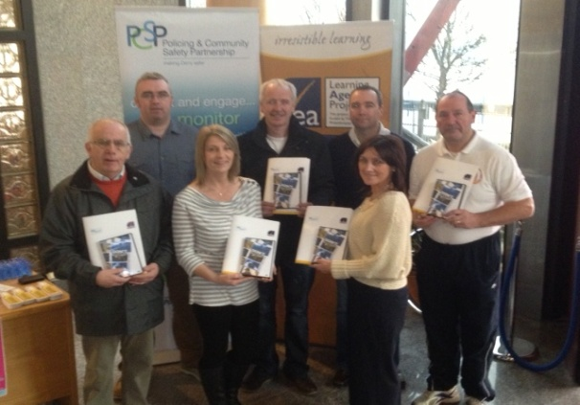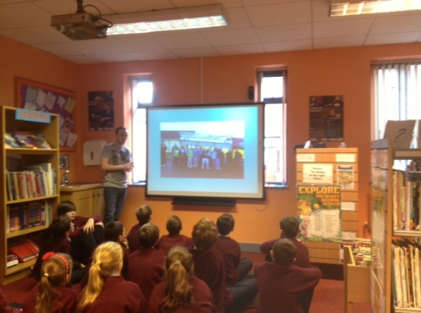  Photo on left- CRJ were asked by the PCSP to roll out the Bogus Caller/Don't Be My Guest Interactive DVD presentation. This has been completed in seven locations to 201 older people. The photograph includes CRJ staff who worked on this Community Safety Initiative.  Photo on Right - Adrian Kelly Outer West volunteer doing a presentation on the harm and the affects of anti -community activity. The presentation was delivered to 19 P7 children in St. Eithne's Primary School. This presentation was part of the NIHE Junior Warden's week.
SM/NPB Comments | The project is coordinating and delivering workshops, multi-agency events and programmes across the 4 city NRAs, implemented primarily through local Primary schools and connecting to a range of service providers. It is building awareness, skills and knowledge amongst young people and having a particular impact on education, community safety and health related priorities identified in each of the Neighbourhood Action Plans.  CRJ enables Triax to deliver on a number of our NAP as it tackles a number of identified needs and priorities, such as;  - Community safety and fear of crime including Anti-community activity, risk taking behaviours, sectarian clashes and nuisance behaviour.  - How an area looks and how it is designed can be a major contributing factor to it feeling unsafe.  - Community isolation among older and vulnerable residents.
Contact Details | Noel McCartney - Community Restorative Justice –  Tel 02871 271131  E- Mail nmccartneycrj@yahoo.ie

Theme | Community - City-Wide Project
Project | Gingerbread NI - One Plus Centre
Aim | This project is focused on the provision of support as a one stop shop for one parent families and through their One Plus Centre to function as a community hub with open access for lone parents seeking support, information, advice, training and childcare all available under one roof. To engage young people in positive activities, improve quality of life for residents, build capacity of residents to address known inadequacies in service delivery themselves, improve community self esteem, improve work readiness of lone parents through innovative training and actions and thus increase employment prospects and rates.
Activities | To lobby and campaign for one parent families and research the needs of one parent families and circulate that information to policy and decision makers. Will tie into the various other strategies and will address the disadvantage experienced by one parent families and promote social inclusion by ensuring ready access to services and information designed to combat the poverty and isolation experienced by many one parent families.
Link to NR Action Plan | Waterside NR Action Plan:  Community Renewal  Social Renewal  Economic Renewal  Outer North NR Action Plan:  Social Renewal  Economic Renewal  Outer West NR Action Plan:  Economic Renewal  Community Renewal  Social Renewal  Cityside NR Action Plan:  Community and Social Renewal  Economic Renewal
Output | To increase the skills base and qualifications in the working age population through improved collaboration and partnership working in order to create a more co-ordinated approach to overcome barriers to employment such as travel, childcare etc.
Outcome | A more cohesive and joined up approach with local stakeholders to support one parent families, volunteering and training to enable them to enter the labour market.
Link to NR Strategy | Community Renewal  Increase in community capacity/capital/cohesion  Increase in the percentage of residents involved in volunteering activities  Economic Renewal Worklessness  Reduction in percentage of population economically inactive  Social Renewal  Family Support
Link to One Plan | Transformational Themes:  Building Better Communities  Employment & Economy  Education & Skills
Photos | Restart Marks: Start Programme:  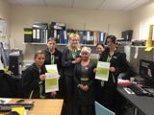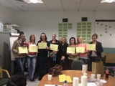
SM/NPB Comments | There has been very limited engagement with or tie-in to Neighbourhood Partnerships or Sub-groups. In the past Gingerbread provided details on participants & beneficiaries residing within NRAs but not in recent times. NPB are more aware of linkage to other NRA / local services such as SureStart, Family Centers etc. The project no doubt provides support to and is improving the prospects of lone parents and their families across the city, not just NRAs.  The Triax NPB would welcome more involvement with Gingerbread NI and would suggest that they increase their partnership working within the NRA to create more awareness to residents as to what support is available to assist in this organisation assisting to deliver on the NAP priority:  - Improve service delivery of providers within Triax as residents have little knowledge of how statutory and other agencies are structured and thus how to go about influencing them.  - Target resources and interventions at Children 0-6.
Contact Details | Maria Fox – Gingerbread NI  Tel: 02871 377066  E-mail: maria@gingerbreadni.org

