Theme | Community  NB This project is Cross Cutting with Community as the main focus
Project | Dove House Community Trust – Core Project
Aim | The aim of the Dove House Community Trust – Core Project is to manage the delivery of four key areas of work that include Neighbourhood Assist; DIVERT (Drug and Alcohol Awareness and Intervention Programme), Youth First and Adult Education & Training Programmes. It offers a comprehensive package of services designed to meet the needs of local residents of all age groups living in the Bogside and neighbouring areas. The project provides initiatives to address crime and anti-social behaviour, health and wellbeing and provides training to address worklessness and education.
Activities | Include:  Provision of a Community Facility; Neighbourhood Assist - Advice Provision;  Divert – Drug & Alcohol Intervention Programmes and Awareness Workshops;  Youth First – Youth Facility providing Youth Initiatives & Diversionary Projects;  Interface Projects; Training and Adult Education Projects; Family Fun Days and Initiatives.
Link to NR Action Plan | Cityside NR Action Plan:  - Economic Renewal  - Community Renewal & Social Renewal
Output | To provide a Community Facility to support and address community issues, such as, advice provision, drug and alcohol awareness and interventions, health issues, youth facilities, diversionary activities, interface programmes, family events and initiatives, training and adult education programmes, community events etc to improve the quality of life for residents living in the Triax NRA.
Outcome | A community facility is available and local residents and youth have accessed an extensive range of community support initiatives including advice provision on benefits, debt, housing issues etc, drug and alcohol interventions, awareness programmes and workshops, support programmes for vulnerable youth and residents, youth facilities for activities, diversionary programmes, cross community and interface programmes, training and adult educational programmes, personal and social development programmes, family fun days etc all of which have provided vital community support in this area of need.
Link to NR Strategy | Crime and Anti-Social Behaviour  Reduction in overall recorded crime rate  Reduction in anti-social behaviour incidents  Community Renewal  Increase in community capacity/capital/cohesion?  Increase in the percentage of residents involved in volunteering activities  Increased satisfaction levels with local environment  Economic Renewal  Increase in number of employee jobs  Reduction in the gap in employment rate  Reduction in percentage of population economically inactive  Health  Increase in overall life expectancy  Reduction in the number of children experiencing harm as a result of parental substance misuse  Reduction in the number of young people using / misusing drug and alcohol  Increase in the number of people more aware of health issues
Link to One Plan | Transformational Themes:  Education & Skills  Employment & Economy  Health & Well Being  Building Better Communities
Photos | Vulnerable Young Persons Project: Drug & Alcohol Awareness Workshop:  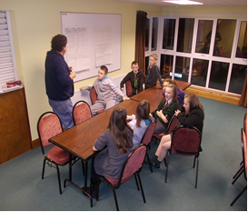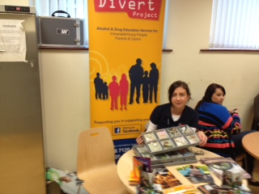
SM/NPB Comments | Dove House Community Trust has been the catalyst for much of the regeneration and community development in what has become known as the Triax area for the past thirty years. From very humble beginnings Dove House has grown to be one of the best known established community organisation delivering services and programmes at a local base through its Advice, Youth and Adult Education services but also on a city wide and regional basis.  Dove House staff are central to many of the innovative and collaborative ways of partnership working that have been established across the Triax Area. With the breadth of work and networks Dove House have they are involved in almost every sub-group and are to the fore on youth and early intervention. Dove House through the breadth of activities and programmes are involved in delivering on almost every priority need identified within the Triax NAP, in particular:  - Help to eradicate poverty by providing welfare/ welfare-to-work, debt advice to maximise income and connect socially excluded residents to neighbourhood services. (NINIS and community consultation).  - Community safety and fear of crime including Anti-community activity, risk taking behaviours, sectarian clashes and nuisance behaviour.  - Improve service delivery of providers within Triax as residents have little knowledge of how statutory and other agencies are structured and thus how to go about influencing them
Contact Details | Bronach McMonagle – Manager  Tel: 02871 273976  Email: bronach@dovehousecommunitytrust.com

Theme | Community
Project | Gasyard Wall Feile – Volunteer Investment Project
Aim | The aim of the Gasyard Wall Feile – Volunteer Investment Project is to promote active citizenship through engagement with individuals living in the Triax Neighbourhood Renewal area. This project professionalises volunteering through a structured recruitment process, provides accredited training, policies and procedures for volunteers and a clear definition of roles and responsibilities. Volunteers are given the opportunity to participate in the Millennium Volunteers Programme where they can obtain a nationally recognised Award of Excellence. This project addresses community renewal through increasing the number of residents involved in volunteering and social renewal through providing alternatives to anti-social behaviour and crime within the TRIAX Action Plan.
Activities | Include:  Promoting Volunteering  Volunteering Opportunities  Volunteer Training Opportunities  Supporting local community events through the provision of Volunteers
Link to NR Action Plan | Cityside NR Action Plan:  - Community Renewal & Social Renewal  - Ecomonic Renewal  - Economic Renewal & Social Renewal
Output | To provide a dedicated Volunteer Investment Project to encourage and promote volunteering and ensure volunteer recruits are provided with any accredited training and professional qualifications to enhance their employability and encourage increased community participation within the Triax Neighbourhood Renewal Area.
Outcome | A Volunteer Investment Project was in place with local residents engaging in the project to access Volunteering Opportunities, availing of Training Opportunities which increased their employability and confidence to support local community organisations and events. The project has increased community capacity and cohesion and has increased self esteem for residents for the Triax NRA. The volunteers were involved in the delivery of programmes, such as, Gasyard Minors, Arts in the Community, Millennium Volunteers, and the many City of Culture events for the 2013 year.
Link to NR Strategy | Community Renewal:  Increase in community capacity/capital/cohesion  Increase in the percentage of residents involved in volunteering activities  Economic Renewal and Worklessness:  Increase in number of employee jobs
Link to One Plan | Transformational Themes:  Employment & Economy  Building Better Communities
Photos | ILM Training – Women Leading the Way: Volunteers at St Paddy’s Day: 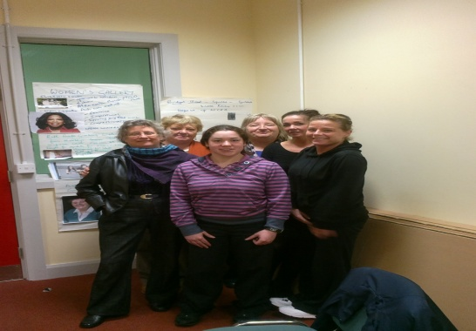 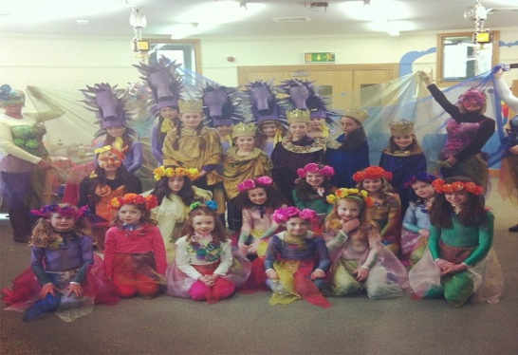
SM/NPB Comments | The Gasyard Feile VIP is an exemplar project for this community in terms of volunteer development and capacity building. The VIP Project is ground breaking in that it not only supports the volunteers to develop and build their skills but it also enables community based organisations to have policies and procedures in place to ensure that they get the best out of volunteering.  This project enables Triax to deliver on its action plan as it contributes to the tackling of a number of identified actions under the priority; Improve service delivery of providers within Triax as residents have little knowledge of how statutory and other agencies are structured and thus how to go about influencing them through recruiting ‘active citizens’ and providing them with the skills necessary to improve service and to create opportunities for residents to engage/volunteer. This assists in meeting the NAP priority:  - Improve service delivery of providers within Triax as residents have little knowledge of how statutory and other agencies are structured and thus how to go about influencing them.
Contact Details | Linda McKinney – GWF Treasurer  Tel: 02871 262812  Email: linsmckinney@yahoo.co.uk

Theme | Community  NB This project is Cross Cutting with Community as the main focus
Project | Cathedral Youth Club – Investing in Young People, Families & The Community
Aim | The aim of the Cathedral Youth Club – Investing in Young People, Families and the Community is to provide positive projects and programmes dealing with issues in the community and interface, engage young people in positive activities thus reducing the level of anti-social behaviour, provide a forum to develop and deliver cross community activities, promote the development of personal and social skills to achieve higher levels of education and employment and to assist young adults in job search and interview skills. The project addresses community development, community safety, health and well being, community education programme, skills and employment & economy, family support etc all of which assist in improving the quality of life for residents living within the area.
Activities | Include:  Community Facility; Youth Club - Drop In Facility; Community Education Programmes; Ulster Scots Music and Dance Programme; Mother and Toddlers Group; Intergenerational Programme; City of Culture Workshops; Young Enterprise Company Programme; Crafty Pieces Quilting Project; 40th Year Gala Evening and Church Service; Young Men’s Health Programme; Growing Together Initiative; Intergenerational Creative Writing Workshops; Walls Project  Portrait of Our City; Community Capacity Building Programme.
Link to NR Action Plan | Cityside NR Action Plan:  - Community Renewal & Social Renewal  - Economic Renewal  - Social Renewal & Physical Renewal  - Economic Renewal & Social Renewal  - Community Renewal & Physical renewal  - Community, Economic, Social & Physical Renewal
Output | To provide a key Community Facility delivering services to the community to increase and promote community renewal through participation in various initiatives to improve the quality of life for residents living in the Triax Neighbourhood Renewal Area.
Outcome | A community facility is available and local residents and youths have accessed activities and facilities in Youth Initiatives, Early Intervention & Family Support, Community Safety Programmes, Training Programmes, Health & Well Being Programmes, Arts & Cultural Programmes, Women’s Activities, Older Peoples Programmes, Family Fun Days and Festivals, Community Relations, Cross Community and Interface Diversionary Initiatives and City of Culture community programmes.
Link to NR Strategy | Community Renewal:  Increase in community capacity/capital/cohesion  Improvement in community relations.  Economic Renewal and Worklessness:  Reduction in gap in employment rate  Reduction in the percentage of population economically inactive  Social Renewal:  Health –  Crime & Anti-Social Behaviour –  Reduction in anti-social behaviour incidents
Link to One Plan | Transformational Themes:  Education & Skills  Employment & Economy  Health & Well Being  Building Better Communities
Photos | Older People’s IT Class: Youth Diversionary Trip:  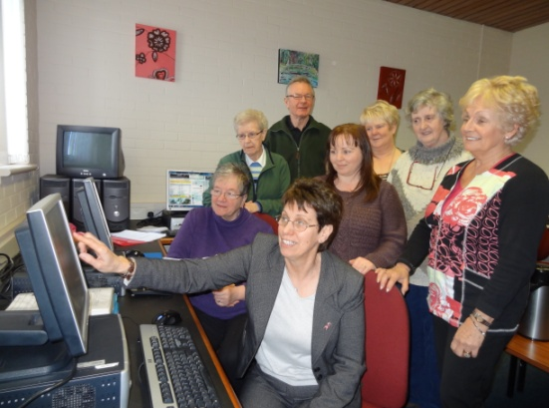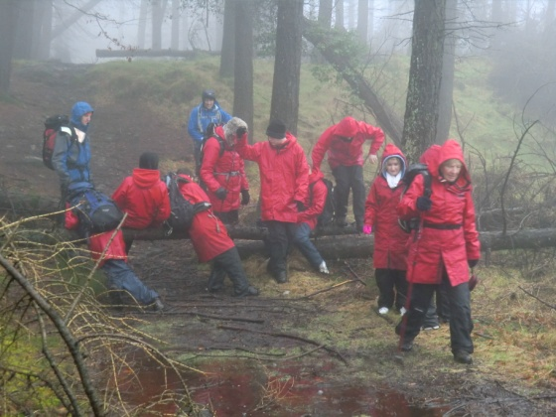
SM/NPB Comments | The Cathedral Youth Club and this project Investing in Families is an essential project for the Triax area and the Fountain Estate. It provides a focal point for the residents of the Estate for many activities, programmes and acts as a community hub. It is essential for the regeneration of the Fountain area that this facility thrives and flourishes.  The Cathedral Youth Club enables Triax to deliver on the NAP as it is often the first point of contact Traix, community organisations and other statutory agencies makes with residents. Staff from the Cathedral Youth Club engage in sub-groups, working groups and local partnerships to address Neighbourhood Renewal and community issues, particularly in terms of interface issues and periods of high tensions.  This project addresses many of the priorities identified within the Triax NAP, in particular:  - Community safety and fear of crime including Anti-community activity, risk taking behaviours, sectarian clashes and nuisance behaviour.  - How an area looks and how it is designed can be a major contributing factor to it feeling unsafe.  - Improve service delivery of providers within Triax as residents have little knowledge of how statutory and other agencies are structured and thus how to go about influencing them.  - Lack of community self esteem, knowledge and understanding of how to improve community and make change.
Contact Details | Jeanette Warke – CYC Manager  Tel: 02871 260483  Email: jeanettewarke@hotmail.co.uk
Theme | Community
Project | Fountain Primary School – Transport Links for Fountain Community
Aim | The aim of the project is to provide social, recreational and cross community activities for pupils, parents, residents and senior citizens including judo, swimming, gardening, music and dance, healthy life style activities, library visits, outdoor play activities, Senior Citizens’ lunch, ‘Cook-It’ and ‘Time for Me’ programmes. The project will continue to develop a confident community and allow members of the community to connect to the wider community within the City, ensure pupils feel that the City is a Shared City and allow parents to develop cross community contacts.
Activities | Include:  Transport of Children to school and activities for-  Senior Citizens lunch ; Judo; Swimming; Health Living Activities; Musical Pathways; Incredible Years (pre-school parents); Extended School Cluster;  Echo Echo dance company; YES project; Teenage Kicks; Bright Brand New Day.
Link to NR Action Plan | Cityside NR Action Plan:  - Community Renewal & Social Renewal
Output | To provide and facilitate services to increase and promote community renewal through participation in various initiatives to improve the quality of life for residents living in the Triax Neighbourhood Renewal Area.
Outcome | A community school facility is available and pupils, parents and local residents and youths have accessed activities for Youth Initiatives, Extended Schools, Healthy Living Centre, Dance, YES Project, teenage Kicks etc all of which assisted to improve community capacity.
Link to NR Strategy | Community Renewal:  Increase in community capacity/capital/cohesion  Improvement in community relations
Link to One Plan | Transformational Themes:  Health & Well Being  Building Better Communities
Photos | Judo Class: Healthy Smile:  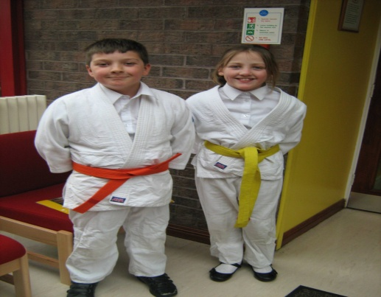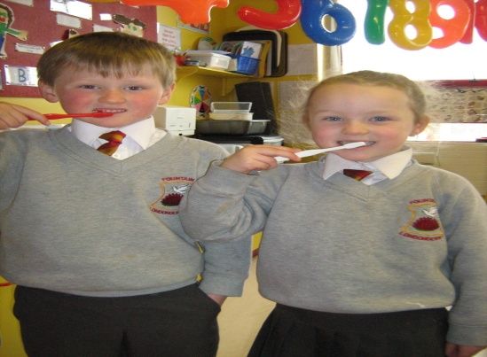
SM/NPB Comments | This project plays an important role ensuring that the Fountain Estate maintains a vibrant and thriving school. Many people believe that if the school was to be lost from the Fountain this could prove fatal for the estate. Triax wants to ensure that Fountain Estate thrives and grows. This project provides social, recreational and cross community activities for pupils, parents, residents and senior citizens creating opportunities for community invovlement.  This project addresses the priorities identified within the Triax NAP of:  - Improve service delivery of providers within Triax as residents have little knowledge of how statutory and other agencies are structured and thus how to go about influencing them.
Contact Details | Cathy Arthur – Principal  Tel: 02871 374909  Email: carthur744@fountainps.londonderry.ni.sch.uk

Theme | Community
Project | Bogside & Brandywell Initiative – Operation Fresh Start/Tus Maith
Aim | The aim of BBI – Operation Fresh Start / Tús Project is to deliver an immediate rapid response team to remove graffiti, fly-tipping and litter etc to prevent areas becoming run down, deliver environmental awareness programmes, deliver workplace training opportunities, deliver volunteering opportunities as well as being the core workforce for Community Improvement Schemes and will work with residents and statutory agencies to tackle long term derelict community hotspots to address and resolve community issues, to promote NR, to assist in the delivery of the NAP priorities therefore improving the quality of life for residents living in the Cityside NR area.
Activities | Include:  Graffiti Removal  Community Clean Ups  Community Improvement Schemes  Community Partnership Working with Residents and Schools  Education and Awareness of Graffiti/Litter etc  Training Placements
Link to NR Action Plan | Cityside NR Action Plan:  - Community Renewal and Social Renewal  - Community Renewal and Physical Renewal  - Economic Renewal  - Social Renewal and Physical Renewal
Output | To provide a rapid response team to remove graffiti, fly-tipping and litter etc to prevent areas becoming run down, deliver environmental awareness programmes, deliver workplace training opportunities, deliver volunteering opportunities, deliver Community Improvement Schemes in partnership with residents and statutory agencies to tackle long term derelict community hotspots and to address and resolve community issues which will improve the quality of life for residents living in the Triax NRA.
Outcome | A team is in place working closely with residents and service providers which has delivered community clean ups, graffiti removal, and has provided volunteering and training opportunities to assist in improving the physical appearance of the NRA which has assisted to enhance the area and the quality of life for residents living within the Triax area. This project will work in partnership with the residents to implement community improvement schemes and educational awareness on litter, graffiti et.
Link to NR Strategy | Community Renewal:  Increase in community capacity/capital/cohesion  Increase in the percentage of residents involved in volunteering activities.  Demographic stability.  Economic Renewal/Worklessness:  Increase in number of employee jobs  Social Renewal:  Crime & Anti-Social Behaviour –  Reduction in overall recorded crime rate  Reduction in violent crime rate  Reduction in burglary crime rate  Reduction in theft crime rate  Reduction in anti-social behaviour incidents  Physical Renewal:  Reduction in area of derelict sites  Increased satisfaction levels with local environment
Link to One Plan | Transformational Themes:  Building Better Communities  Employment & Economy  Health & Well Being
Photos | Sean Dolan’s Clean Up: Community Clean Up – St Josephs Place:  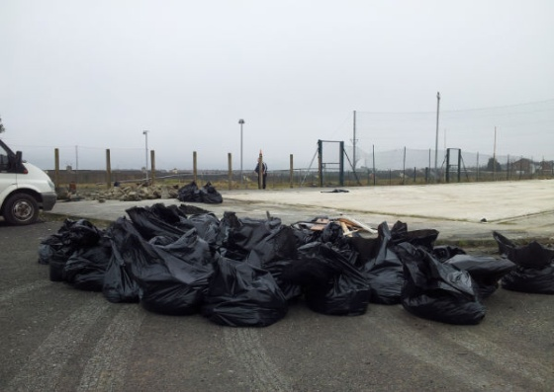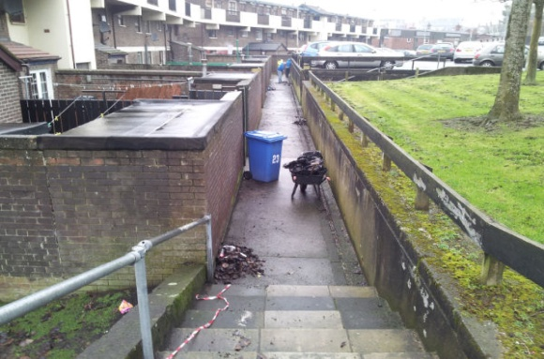
SM/NPB Comments | This is a fairly new project and only began in March 2013. Triax would be very confident that this project will have a major impact on this community and will help to deliver a number of identified npriorities in our NAP;  - Community safety and fear of crime including Anti-community activity, risk taking behaviours, sectarian clashes and nuisance behaviour.  - How an area looks and how it is designed can be a major contributing factor to it feeling unsafe.  - Community isolation among older and vulnerable residents  - Barriers to employment, lack of skills and qualifications needed for employment has been a major issues in this community for decades.
Contact Details | Sean McMonagle – BBI Manager  Tel: 02871 261916  Email: seanmcconagle@hotmail.com

