Theme | Social - City-Wide Project
Project | Western Health & Social Services Board - Neighbourhood Health Improvement Project
Aim | The aim of the project is to develop an integrated and collaborative approach to addressing health improvement
Activities | Neighbourhood Health Improvement Project:  The project is developing a process to enable communities in each Neighbourhood Renewal Area to improve their health and well-being.and recognises that each NRA is at a different level of capacity, development, population size etc and as a result the project seeks to provide appropriate supports to each NRA. The project aims to add value to existing work by developing a new way of addressing health improvement in NRAs through a collaborative and integrated approach.
Link to NR Action Plan | It addresses the following Themes in the six North West Action Plans:  - Community Renewal  - Social Renewal
Output | Each health forum within the NRAs has a one year action plan. Action plans will include and allow for the following:  - Findings from Phase 2 evaluation  - Identified need in the local area  - Coordinated actions across NRAs  - Capacity building on health improvement  - Early intervention  - Utilise existing initiatives (in particular those with no cost)  - Avoid duplication  - Added value  - Evidence based activities
Outcome | Communities in each NRA are better able to support planning and delivery of health improvement initiatives through development of expertise in the community  Health awareness of people participating is improved. People living in NRAs have improved access to health services and benefits. Partnerships work collaboratively to address health needs, sharing good practice and working together. Health improvement activities are undertaken in an equitable way.
Link to NR Strategy | It addresses the following Themes in the six North West Action Plans:  - Community Renewal  - Social Renewal
Link to One Plan | The key determinants of health and wellbeing are low income, unemployment, poor environment, diet, lack of physical activity, smoking, alcohol and drug misuse, poor education and substandard housing. Improving health and well-being by tackling health inequalities requires action and investment across government departments to tackle the root causes of health. The NHIP project will see government and the community and voluntary sector work together to deliver programmes to improve community health and well-being whilst at the same time improving community capacity.
Photos | To insert
SM/NPB Comments | The Neighbourhood Health Improvement Project has made a positive impact in the Neighbourhood Renewal Area supporting and developing existing work in the area. However it is felt that some consideration needs to be given to the delivery model. The development of a NHIP Health Action Plan in the area has allowed groups to identify local need and gaps in current service provision and tailor service delivery to meet need. The project has assisted in addressing actions within the Neighbourhood Action Plan by targeting issues link to identified needs;  - Health Inequalities and poor health have been a fact of life in this and other working class deprived communities for decades. The key health issues to be tackled in this community are;  Cancer Prevention, Mental Health, Suicide Prevention, Obesity, Prescription Drugs, Alcohol, Illegal Drugs and Substance Misuse, Dental Decay, Accidents at Home, Promoting Positive Relationships Among Young People, Sexual Health.
Contact Details | Dr Maura O’Neill – WHSCT – Health Improvement Team  E-Mail Maura.ONeill@westerntrust.hscni.net

Theme | Community  NB This project is Cross Cutting with Community as the main focus
Project | Triax Ltd – Triax Neighbourhood Partnership Technical Assistance
Aim | This project provides the Technical Assistance required for the Triax Neighbourhood Partnership Board to take the lead in managing the Neighbourhood Renewal process in the Cityside Neighbourhood Renewal area and to implement the Triax Neighbourhood Renewal Action Plan which addresses all 4 strategic objectives of Neighbourhood Renewal.
Activities | Include:  Facilitation of the development and implementation of the Triax Action Plan as a working document  Engagement with relevant organisations within the NRA to continue to develop new service delivery models to develop priorities and outcomes identified in the Action Plan  Engagement with relevant statutory bodies and non-Government funding bodies to lever additional funding to deliver priorities identified in Action Plan  Enable residents and community/voluntary groups in the Triax area to engage effectively in reviewing their own neighbourhoods  Identify and promote capacity measures  Facilitation of NPB and Sub Group Meetings  Engagement with older people in the Fountain in a range of social, health, intergenerational and cross community events and programmes
Link to NR Action Plan | Cityside NR Action Plan:  - Community Renewal and Social Renewal  - Community Renewal and Physical Renewal  - Community, Economic, Social and Physical Renewal  - Economic Renewal  - Economic Renewal and Social Renewal  - Social Renewal  - Social Renewal and Physical Renewal
Output | To facilitate the development and implementation of the Triax Neighbourhood Renewal Action Plan.
Outcome | The Triax Action Plan is being delivered/developed as a working document and the action priorities are delivering to assist in closing the gap between those living in the Triax Neighbourhood Renewal Area and the rest of society, where possible. The Triax NRA now has a strong community and voluntary sector with many projects in place to actively improve the social, community, economic and physical renewal in this area and work through the Sub Groups is ongoing to address priorities that need developed .
Link to NR Strategy | Community Renewal:  Increase in community capacity  Increase in the percentage of residents involved in volunteering activities  Improvement in community relations  Demographic stability  Economic Renewal and Worklessness:  Increase in number of employee jobs  Reduction in gap in employment rate  Reduction in the percentage of population economically inactive  Increase in proportion of business start-ups  Number of oupils benefiting from projects designed to improve attanment  Social Renewal:  Education –  Reducation in percentage of school leavers with no GCSE’s  Health –  Increase in overall life expectancy (males and females)  Reducation in percentage of deaths under 75  Reducation in life suicide rate (males and females)  Reduction of births to teenage mothers  Crime & Anti-Social Behaviour –  Reduction in violent crime rate  Reduction in anti-social behaviour incidents  Physical Renewal –  Reduction in area of derelict sites  Increased satisfaction levels with local environment  Increase in number/quality of community facilities
Link to One Plan | Transformational Themes:  Building Better Communities  Education & Skills  Employment & Economy  Health & Well Being  Sustainable & Connected City Region
Photos | To insert
SM/NPB Comments | It is important for the development, co-ordination, delivery and success of the Neighbourhood Action Plan that Technical Assistance is provided by the Department to the Neighbourhood Partnership Boards.  Triax Ltd through the Neighbourhood Partnership Board have continued to develop the Triax Action Plan as a working document to address community issues and priorities and to take the lead in managing the Neighbourhood Renewal process in the Cityside Neighbourhood Renewal area by implementing priorities within the Triax Neighbourhood Renewal Action Plan addressing all 4 strategic the Economic, Physical, Social and Community objectives of Neighbourhood Renewal.
Contact Details | Charles Lamberton – Triax Strategy Manager  Tel: 02871 367007  Email: Charles@triaxtaskforce.org

Theme | Community  NB This project is Cross Cutting with Community as the main focus
Project | Bogside & Brandywell Initiative – Triax Neighbourhood Management Team
Aim | The aim of the Bogside & Brandywell Initiative – Triax Neighbourhood Management Team is to provide a strategic development team within the Cityside NRA as an integrated unit designed to plan, develop, implement, monitor and review key activities and programmes that will facilitate the achievement of the strategic objectives of NR. This team co-ordinates and facilitates the inclusion and participation of local residents, community groups and statutory agencies to address and resolve community issues, to promote NR, to assist in the delivery of the NAP priorities therefore improving the quality of life for residents living in the Cityside NR area.
Activities | Include:  Resident Engagement; Interface Engagement; Statutory Engagement on local issues; Physical Environment Initiatives eg Graffiti; Community Maintenance & Improvements; Anti-social Behaviour Initiatives; Bonfire Initiatives; Community Safety Initiatives re Community Safety Forum; Youth Initiatives re Youth Sub Group; School Engagement Programmes for local Initiatives; Information Workshop in Fountain iro services delivered for area; Operation Snowball.
Link to NR Action Plan | Cityside NR Action Plan:  - Economic Renewal  - Economic Renewal and Social Renewal  - Community, Economic, Social and Physical Renewal  - Community Renewal and Social Renewal  - Community Renewal and Physical Renewal  - Social Renewal and Physical Renewal
Output | To provide a Triax Neighbourhood Management Team within the Cityside Neighbourhood Renewal Area with the core function of having an integrated unit designed to plan, develop, implement, monitor and review key activities and programmes that will facilitate the achievement of the strategic objectives of Neighbourhood Renewal.
Outcome | A team is in place working closely with residents at ground level and service providers addressing local issues and delivering environmental projects, community clean ups, graffiti removal, traffic calming, resident parking, diversionary youth activities, support for interface tensions, summer programmes, allotment schemes, street planning for social housing developments, lobbying for key infrastructural developments in the area, and community safety initiatives all of which have assisted in improving the quality of life for residents in the Triax NRA.
Link to NR Strategy | Community Renewal:  Increase in community capacity  Increase in the percentage of residents involved in volunteering activities  Improvement in community relations  Social Renewal:  Crime & Anti-Social Behaviour  Reduction in violent crime rate  Reduction in anti-social behaviour incidents  Economic Renewal and Worklessness:  Reduction in the percentage of population economically inactive  Increase in proportion of business start-ups
Link to One Plan | Transformational Themes:  Building Better Communities  Employment & Economy
Photos | BBI Fountain NR Workshop: BBI Youth Initiative 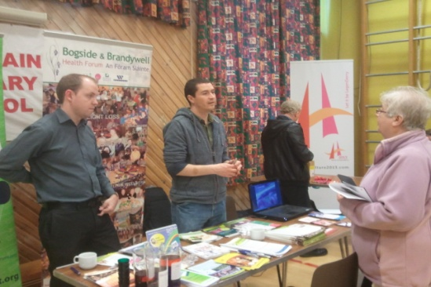 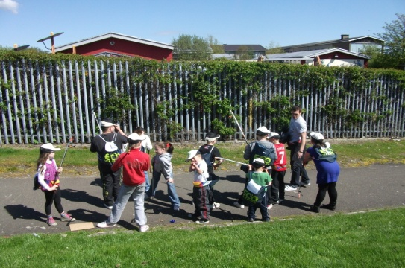
SM/NPB Comments | The Triax Neighbourhood Management Team play vital role in the development and delivery of the Triax Neighbourhood Action Plan and wider Neighbourhood Renewal Strategy. The NMT are often the first interface between residents and service providers. The engagement of residents and the delivery of frontline services often build the confidence of residents to become more engaged in the various community and statutory services available across this area.  The NMT team staff are involved in numerous Triax sub-group, working groups and local partnership and play a central role in community safety, youth engagement and the physical environment.  The NMT team help deliver Neighbourhood Action Plan by engaging with residents and delivering on a number of identified priorities;  - Community safety and fear of crime including Anti-community activity, risk taking behaviours, sectarian clashes and nuisance behaviour.  - How an area looks and how it is designed can be a major contributing factor to it feeling unsafe.  - Improve service delivery of providers within Triax as residents have little knowledge of how statutory and other agencies are structured and thus how to go about influencing them  - Lack of community self-esteem, knowledge and understanding of how to improve community and make change.  - To improve the local environment in terms of, physical environment i.e. graffiti, litter, biodiversity i.e. green spaces, planting, priority species.
Contact Details | Sean McMonagle – BBI Manager  Tel: 02871 261916  Email: seanmcconagle@hotmail.com

Theme | Community  NB This project is Cross Cutting with Community as the main focus
Project | Creggan Country Park Enterprises Ltd – Neighbourhood Renewal Support Project
Aim | The aim of Creggan Country Park – NR Support Project is to assist in the provision of a key environmental and social economy organisation, Country Park & Activity Centre within the Cityside NRA with the core function of delivering a range of services and activities, such as, provision of outdoor activities and facilities to promote active lifestyle and healthy living, provision of volunteering and training projects to enhance skills and employability including placement based training, environmental improvement projects to enhance local green space, environmental projects and programmes including environmental education, to promote volunteering and to deliver youth initiatives linking education with activity all of which advocate community involvement, healthy lifestyles and environmental friendly initiatives to improve the quality of life within the Cityside NRA.
Activities | Include:  Environmental Education and Outreach  Volunteering  Tree planting  Clean ups  Habitat Survey and Management Plans  Watersports and Outdoor Pursuits
Link to NR Action Plan | Cityside NR Action Plan:  - Community Renewal & Social Renewal  - Social Renewal  - Economic Renewal  - Community, Economic,Social and Physical Renewal
Output | To provide a key environmental and social economy organisation and Country Park facility within the Cityside Neighbourhood Renewal Area.
Outcome | A Country Park and Activity Centre facility is available and local residents, community organisations and schools have accessed outdoor activities and facilities, youth diversionary and cross community initiatives, environmental improvement projects, tree planting, improving green spaces, environmental education programmes, volunteering opportunities, training opportunities etc all of which advocated community involvement, promoted volunteering and training initiatives, healthy lifestyles, environmental improvements and environmental friendly initiatives.
Link to NR Strategy | Social Renewal:  Health – Increase in overall life expectancy  Economic Renewal/Worklessness:  Increase in number of employee jobs  Reduction in percentage of population economically inactive  Physical Renewal:  Reduction in area of derelict sites
Link to One Plan | Transformational Themes:  Building Better Communities  Employment & Economy
Photos | Creggan Country Park Centre: Team building – Canoeing  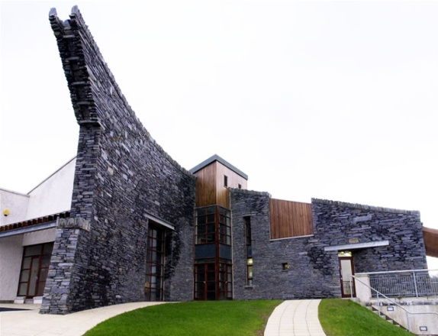
SM/NPB Comments | Creggan Country Park (CCP) offers a wide range of sporting, outdoor activity, teambuilding, environmental and leisure activities, programmes and services to residents, schools, community organisations, youth organisations and sporting clubs. This award winning facility in the heart of Creggan is an example of how communities working together with a vision can deliver real and meaningful change.  Staff at CCP have been to the fore in driving the Neighbourhood Renewal Strategy in this area and are involved a number of sub groups. CCP take the laed and chair the Triax Environemtal Sub Group. CCP ensure that Triax delivers on the NAP by providing leadership and support in a number of identified actions and priorities;  - Community safety and fear of crime including Anti-community activity, risk taking behaviours, sectarian clashes and nuisance behaviour.  - How an area looks and how it is designed can be a major contributing factor to it feeling unsafe.  - To improve the local environment in terms of, physical environment i.e. graffiti, litter, biodiversity i.e. green spaces, planting, priority species
Contact Details | Gerry Quinn – CCP Manager  Tel: 02871 363133  Email: Gerry.quinn@creggancountrypark.com

Theme | Community  NB This project is Cross Cutting with Community as the main focus
Project | Gasyard Development Trust – Salaries & Running Costs
Aim | The aim of the Gasyard Development Trust (GDT) – Core Salaries Project is to work directly with early learning years, youth and older people in providing learning and programme activities. GDT manages the Gasyard Centre, which is a facility that delivers services to the community ranging from Arts & Culture, health, education, children’s services, volunteering, community safety and a community cafe that targets all generations of our community who live in a seriously deprived neighbourhood. It uses its resources, both capital and human, to improve the quality of life of those living in neighbourhood renewal communities. We work with disadvantaged people tackling social, educational and economic regeneration. We reach out to disengaged and unattached residents and provide programmes focusing on their strengths and developing their skills base and self-esteem. The project addresses community safety, health and well being, education and skills and employment and economy within the Triax Action Plan.
Activities | Include:  Provision of a Community Facility; Early Intervention & Family Support; Community Safety Programmes; Training Programmes; Health & Well Being Programmes; Arts & Cultural Programmes; Children’s Services; Women’s Activities; Family Fun Days and Festivals; Community Relations; City of Culture – Music Promise.
Link to NR Action Plan | Cityside NR Action Plan:  - Economic Renewal  - Social Renewal  - Community Renewal & Social Renewal
Output | To provide a key Community Facility delivering services to the community to increase and promote community participation in initiatives to improve the quality of life for residents living in the Triax Neighbourhood Renewal Area.
Outcome | A community facility is available and local residents, community organisations and schools have accessed activities and facilities in Early Intervention & Family Support, Community Safety Programmes, Training Programmes, Health & Well Being Programmes, Arts & Cultural Programmes, Children’s Services, Women’s Activities, Family Fun Days and Festivals, Community Relations and City of Culture community programmes, such as, Music Promise.
Link to NR Strategy | Community Renewal:  Increase in community capacity  Improvement in community relations  Economic Renewal and Worklessness:  Reduction in gap in employment rate  Reduction in the percentage of population economically inactive  Increase in the percentage of the working age population qualified to level 2+  Social Renewal:  Health –  Increase in overall life expectancy (males and females)  Crime & Anti-Social Behaviour –  Reduction in anti-social behaviour incidents
Link to One Plan | Transformational Themes:  Education & Skills  Employment & Economy  Health & Well Being  Building Better Communities
Photos | Gasyard Centre: Family Fun Day:  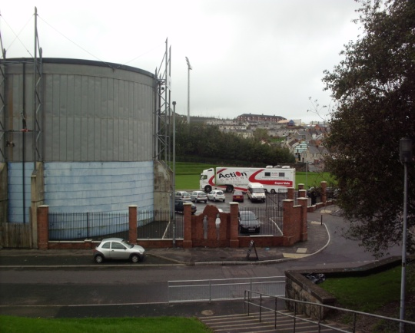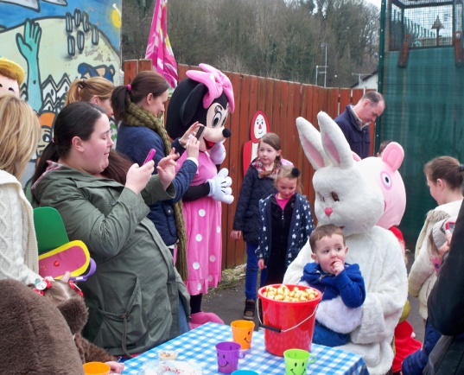
SM/NPB Comments | The Gasyard Development Trust (GDT) and the Gasyard Centre are integral to the Regeneration and Neighbourhood Renewal Process that is taking place across the Bogside and Brandywell areas. The GDT offers programmes and services to a range of community organisations, schools, youth groups, sporting groups, cultural groups and residents. These cover a wide range of topics from education, health, arts and culture, environmental and community safety.  The Gasyard is home to a number of community based organisations such as the Bogside and Brandywell Initiative, Bogside and Brandywell Health Forum, FEILE, Derry 2020 and the Bluebell Arts Project.  Staff from the GDT are involved in numerous sub-groups, working groups and local partnerships a play a leading role in the Cultural. Arts and Heritage product in this area. The GDT and the tenants of the centre play a role in every part of the NAP, in particular:  - Community safety and fear of crime including Anti-community activity, risk taking behaviours, sectarian clashes and nuisance behaviour.  - Improve service delivery of providers within Triax as residents have little knowledge of how statutory and other agencies are structured and thus how to go about influencing them  - Barriers to employment, lack of skills and qualifications needed for employment has been a major issue in this community for decades.
Contact Details | Linda McKinney – GDT Manager  Tel: 02871 262812  Email: linsmckinney@yahoo.co.uk

Theme | Community  NB This project is Cross Cutting with Community as the main focus
Project | Creggan Pre-school & Training Trust – Family Support Project
Aim | The aim of the Creggan Pre-school & Training Trust – Family Support Project is to work directly with early learning years, youth and older people in providing learning and programme activities. CPTT carry this out by working collaboratively with a wide number of statutory and voluntary & community organisations and agencies addressing issues and needs that affect local residents and people. The project addresses education, health and youth within the Triax Action Plan.
Activities | Include:  Provision of a Community Facility  Adult Education Programmes - accredited and non- accredited courses  Parenting, Environmental and Health Initiatives  Community Playgroup  Creche Facilities for course participant children and also respite  Weekly Parent & Toddler sessions and programmes  After Schools Club programme  Women’s Programmes  Family Fun Days and Initiatives  Single Identity Programmes
Link to NR Action Plan | Cityside NR Action Plan:  - Economic Renewal  - Social Renewal  - Community Renewal & Social Renewal
Output | To provide a Community Facility to increase and promote family support, adult education programmes and accessible childcare to improve the quality of life for residents living in the Triax Neighbourhood Renewal Area.
Outcome | A community facility is available and local residents have accessed an extensive range of adult education programmes, including Literacy, Numeracy, IT, Healthy Eating, etc alongside Parenting, Environmental and Health Initiatives, a community playgroup, creche facilities, Parent & Toddler programmes, an After Schools Club programme, personal and social development programmes, family fun days etc all of which have provided family support and promoted education and healthy living.
Link to NR Strategy | Community Renewal:  Increase in community capacity  Increase in the percentage of residents involved in volunteering activities  Economic Renewal and Worklessness:  Increase in number of employee jobs  Reduction in gap in employment rate  Reduction in the percentage of population economically inactive  Reduction in percentage of school leavers with no GCSE’s  Social Renewal:  Health –  Increase in overall life expectancy (males and females)  Physical Renewal:  Increase in number/quality of community facilities
Link to One Plan | Transformational Themes:  Education & Skills  Employment & Economy  Health & Well Being  Building Better Communities
Photos | CPTT Creche: Women Leading the Way Course:  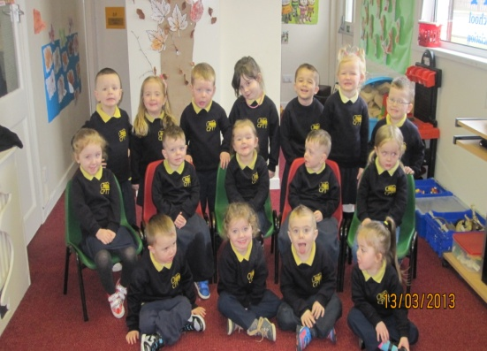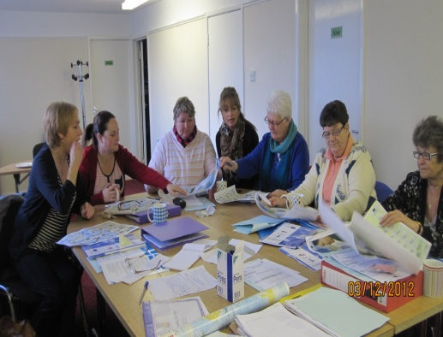
SM/NPB Comments | Creggan Pre-school Training Trust is one of the longest running community organisations in the area and provides a range of services for children, young people and adults. Staff from CPTT are involved in number of sub-groups, working groups and local partnerships.  CPPT have a very successful Adult Education Programme in partnership with North West Regional College and the local Extended Schools Cluster.  The work of CPTT enables Triax to deliver on the NAP as they contribute to a number of identified needs and priorities;  - Health Inequalities and poor health have been a fact of life in this and other working class deprived communities for decades. The key health issues to be tackled in this community are; Cancer Prevention, Mental Health, Suicide Prevention, Obesity, Prescription Drugs, Alcohol, Illegal Drugs and Substance Misuse, Dental Decay, Accidents at Home, Promoting Positive Relationships Among Young People, Sexual Health,  - Target resources and interventions at Children 0-6.  - The numbers of young people leaving school without what is regarded as adequate qualifications i.e 5 GCSE including Maths and English alongside the number of adults without any formal qualifications is well above the regional average. This is compounded by the fact that the amount of residents with a degree is disproportionally low.
Contact Details | Louise McIntyre – Education Officer  Tel: 02871 267060  Email: louise@cpttderry.org

