Theme | Social
Project | Old Library Trust – The Healthy Living Centre
Aim | The Old Library Trust, Healthy Living Centre provides neighbourhood-based social & health care programmes & services designed to improve health and wellbeing within Creggan, an area falling within the top 10% most disadvantaged electoral wards in NI. The OLT works in partnership with local residents, community groups, public health and social care providers. Over 50 programmes and services are delivered annually across identified key areas of delivery, these are Support for Older People, Providing access to Primary Care Services at the Neighbourhood Level, Promoting Physical Activity to sedentary adults, Assisting those with long term conditions, Addressing the obesity epidemic via the family approach, Providing specialist support to those with lung conditions, Promoting Dental Health and Support to families with children aged 0-4.
Activities | Include:  Provision of a Healthy Living & Learning Centre Facility  Health For Life Project - meeting older people’s needs across the Triax Area - Gym N Spin Exercise, Gentle Yoga, Walking Club, Line Dancing, Boccia & Kurling Practice, Foot Care Clinic, Diabetes Walk In Clinic, Memory Morning for dementia sufferers, Lunch Club, Knitting Class, Evening Drop In, Daytime Drop In, Crocheting, Smoking Cessation, Arthritis Support Group and Spring Dance.  Exercise For All - community exercise programme offering different types of physical activity that suits all ages, levels and abilities – Spinning, Pilates, Pump, Strength & Conditioning, Kettlebells, BOLT Running Club, Step Up (GP Referral Programme), Get Active (GP Referral Specific to Lung Conditions), Get Active (GP Referral Specific to Diabetes), Fight Club, Mix it Up Beginners Class, Yoga Evening, Zumba, Bums n Tums, Weigh n Go and Boxercise.  Derry Breathe Easy - support for those with respiratory conditions across the Derry Area - Healthy Eating & Your Lungs.  SWEET - Safe, Wellbeing, Exercise and Eating Together aimed at trying to combat child obesity using the whole family approach.
Link to NR Action Plan | Cityside NR Action Plan:  - Community Renewal & Social Renewal
Output | To provide a vibrant Healthy Living Centre, focused on, providing access to a wide range of community and primary care services including crèche, speech and language therapy, podiatry, dental health care, mental health support, healthy eating , promoting healthier lifestyles, smoking cessation, action cancer, community healing, exercise referral and physical activity and sport in collaboration and partnership with WHSCT, PHA, DCC and other stakeholders to tackle deprivation with the accessibility of service provision to meet the identified needs and improve the quality of life for residents living in the Triax NRA.
Outcome | A vibrant Healthy Living Centre is open to the public and there is an increase in the number of local residents, community organisations and schools, accessing the facility and the health initiative projects, such as, the Health For Life Project for older people’s needs which includes Gym N Spin Exercise, Gentle Yoga, Walking Club etc, the Exercise For All community exercise programme offering different types of physical activity, such as, Spinning, Pilates, Pump, Strength & Conditioning, BOLT Running Club etc, the Derry Breathe Easy support for those with respiratory conditions, and the SWEET - Safe, Wellbeing, Exercise and Eating Together project aimed at trying to combat child obesity using the whole family approach etc. All programmes have assisted this community to have accessible programmes to improve health and wellbeing and improve the quality of life for residents living within the Triax NRA.
Link to NR Strategy | Community Renewal:  Increase in community capacity/capital/cohesion  Social Renewal:  Health –  Increase in overall life expectancy (males and females)  Reduction in percentage of deaths under 75
Link to One Plan | Transformational Themes:  Building Better Communities  Health & Well Being
Photos | OLT – Healthy Living Centre: Bolt Running Initiative:  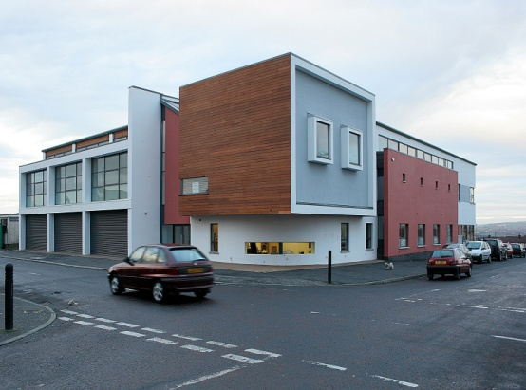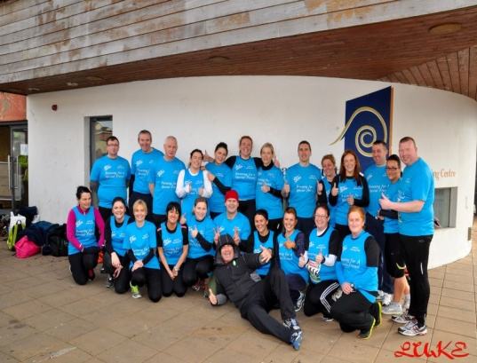
SM/NPB Comments | The Old Library Trust Healthy Living Centre is central to the process of Regeneration and Neighbourhood Renewal that is currently taking place in the Triax area. The development of the Lis Linn Centre was the catalyst for much of the regeneration in Creggan, which has seen the new park and sports centre being developed alongside.  The OLT play a crucial and central role in a number of working and sub-group with a particular focus on the Triax Health Sub-group and implementation of the Health Actions within the Triax NAP, under the NAP priority:  - Health Inequalities and poor health have been a fact of life in this and other working class deprived communities for decades.  Over 1000 people per week use the various health and well being services being delivered by the OLT. The OLT works with or provides space within the centre for all ages and sectors. Alongside this the OLT works across the area in partnership and collaboration with many groups, organisations, schools and residents. They have a very interactive Facebook presence and are constantly engaging with residents and stakeholders.
Contact Details | Seamas Heaney – Director  Tel: 02871 373870  Email: seamas@olt.ie
Theme | Social
Project | Dove House Community Trust – Advice Project
Aim | The aim of the Dove House Community Trust – Advice Workers Salaries is the delivery of the Neighbourhood Assist project through the provision of advice on a wide range of social security benefits, debt management, welfare rights etc. The project encourages the take up of social security benefits, increases capacity building and addresses poor health, unemployment, low income, housing and welfare rights.
Activities | Include:  Provision of a Community Facility  Neighbourhood Assist - Advice Provision  Advise Awareness Workshops  Advice Outreach
Link to NR Action Plan | Cityside NR Action Plan:  - Community Renewal & Social Renewal  - Economic Renewal
Output | To provide a Community Facility to support and address community issues and provide the relevant advice to ensure residents are aware of benefit uptake welfare rights etc. to improve the quality of life for residents living in the Triax Neighbourhood Renewal Area.
Outcome | A community facility is available and local residents have accessed the Neighbourhood Assist project and outreach clinics to access advice on debt, changes to benefits, housing issues, disability rights, unemployment advice, low income advice, welfare rights etc all of which have provided vital community support in this area of need.
Link to NR Strategy | Community Renewal:  Improvement in Community relations  Increase community capacity/capital/cohesion  Increase in the percentage of residents involved in volunteering activities  Social Renewal:  Health  Increase overall life expectancy  Reduction in percentage of deaths under 75  Crime and anti-social behaviour  Reduction in crime and anti-social behaviour  Economic Renewal:  Increase in the number of employee jobs  Reduction in the gap in employment rate  Reduction in the percentage of population economically inactive.
Link to One Plan | Transformational Themes:  Employment & Economy  Health & Well Being  Building Better Communities
Photos | Debt Advice Launch: Panel highlighting Welfare Reform:  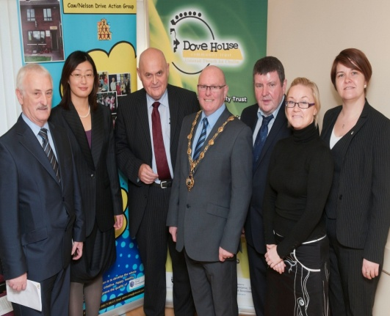
SM/NPB Comments | Dove House Community Trust – Advice Project is on the frontline dealing with the day to day reality of poverty and deprivation in the Triax area. The drop in service is operational five days a weeks, with outreach services to older and vulnerable people. They also promote and actively encourage residents to take up the benefits they are entitled to. Alongside this Dove House are very active in campaigning and highlighting issues of concern both on the streets, in the media and to politicians.  The current economic climate, the rising number of people unemployed, the impending attack on those on benefits dressed up as Welfare Reform and increasing levels of personal debt have put massive strain on communities and residents living in Neighbourhood Renewal Areas and it is these issues that Dove House Advice Services are tackling and having a direct impact on the delivery of the Triax Neighbourhood Action Plan, in particular:  - Help to eradicate poverty by providing welfare/ welfare-to-work, debt advice to maximise income and connect socially excluded residents to neighbourhood services. (NINIS and community consultation).
Contact Details | Bronach McMonagle – Manager  Tel: 02871 273976  Email: bronach@dovehousecommunitytrust.com

Theme | Social - City-Wide Project
Project | The Pink Ladies Breast Cancer Support Group – Community Cancer Support
Aim | This project is focused on delivering counselling, complimentary therapies, listening ear services, individual and group support, sign posting, positive living programmes, health promotion and education, awareness campaigns, accredited counselling training for residents etc for cancer support. The project will be delivered in community settings in each of the NR areas across the City and will address the implementation of Neighbourhood Renewal Action Plans across the City.
Activities | Include:  Counselling Services  Complimentary Therapies  Training Services  Individual and Group Support  Cancer Awareness Campaigns
Link to NR Action Plan | Cityside NR Action Plan:  - Community Renewal & Social Renewal  - Economic Renewal  Outer North NR Action Plan:  - Community Renewal  - Economic Renewal  - Social Renewal  Outer West NR Action Plan:  - Community Renewal  - Social Renewal  - Economic Renewal  Waterside NR Action Plan:  - Social Renewal  - Economic Renewal
Output | To deliver a community support service for residents living across the 4 NRA’s who are undergoing cancer treatment and their families in partnership with Action Cancer.
Outcome | The Pink Ladies Co-ordinator is working with the 4 NRA’s delivering counselling, complimentary therapies, listening ear services, individual and group support, sign posting, positive living programmes, health promotion, awareness campaigns, accredited counselling training to residents from local venues within Triax, Waterside, Outer North and this will be expanded to include the Outer West NRA.
Link to NR Strategy | Community Renewal:  Increase in community capacity/capital/cohesion  Increase in the percentage of residents involved in volunteering activities  Economic Renewal/Worklessness:  Increase in number of employee jobs  Social Renewal - Health:  Increase in overall life expectancy  Increase in life expectancy for males  Increase in life expectancy for females Reduction in percentage of deaths under 75  Reduction in the percentage receiving DLA and Incapacity Benefit.
Link to One Plan | Transformational Themes:  Building Better Communities  Education & Skills  Employment & Economy  Health & Well Being
Photos | Pink Ladies Volunteers: Pink Ladies & Action Cancer Launch:  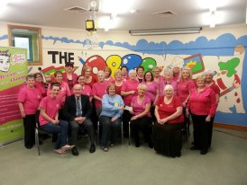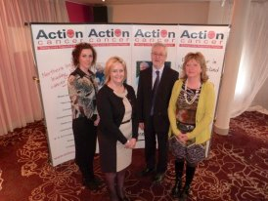
SM/NPB Comments | The Pink Ladies has established itself within the Neighbourhood Renewal Area becoming the go-to service for cancer support and prevention services. The project is represented on the Health Sub-Group and has contributed to the action planning process. It works at a neighbourhood level and its impact on the Neighbourhood Action Plan has been positive impacting on actions within Community Renewal, Economic Renewal and Social Renewal – Health.  Alongside the awareness raising and support services and programmes that the Pink Ladies deliver, they have developed into a very strong lobbying and campaigning group on many issues that effect cancer patients and others.  Cancer prevention and support has been identified as a key priority for Triax in our NAP and our NHIP Action and delivery plan.  The Pink ladies play an integral role in the delivery of the Triax Action Plan;  - Health Inequalities and poor health have been a fact of life in this and other working class deprived communities for decades. The key health issues to be tackled in this community are;  Cancer Prevention, Mental Health, Suicide Prevention, Obesity, Prescription Drugs, Alcohol, Illegal Drugs and Substance Misuse, Dental Decay, Accidents at Home, Promoting Positive Relationships Among Young People, Sexual Health,
Contact Details | Michelle McLean – The Pink Ladies Breast Cancer Support Group  Tel: 02871 347515  Email: pinkladiesderry@hotmail.co.uk

Theme | Social - City-Wide Project
Project | DSD Housing Division: Northern Ireland Housing Executive - Social Education Programme
Aim | The aim of the Project is to give local children the opportunity to learn more about, and to have an opportunity to positively participate with their local community; whilst at the same time building their self respect, their sense of responsibility and ability to positively, rather than negatively, affect their local community, thus reducing the potential for ASB/Crime in their local areas. The Project provides constructive activities for local young people that benefit the community, whilst encouraging a sense of civic responsibility and pride, building community capacity, promoting partnership/collaborative working and good community relations, developing leadership’s skills and providing opportunities for intergeneration interaction. As well as contributing to a safer, cleaner environment the project will enable the young people to meet new friends, develop new skills and ultimately to have fun
Activities | Training young people to provide community activities such as through a Junior Warden Scheme leading to safer and cleaner environment.
Link to NR Action Plan | Cityside NR Action Plan:  - Community Renewal & Social Renewal  Waterside NR Action Plan:  - Community Renewal  - Social Renewal  Outer West NR Action Plan:  - Community Renewal  - Social Renewal  Outer North NR Action Plan:  - Community Renewal  - Social Renewal
Output | To deliver a social and community service for the benefit of the NR Area environments through a ‘Junior Warden Scheme’ which focuses on Young people of School age taking responsibility in providing a safer and cleaner environment for all residents throughout each of the Citywide NR Areas.
Outcome | Young People trained and in place to support each of the 4 x NRA’s to assist in self development and striving to make each NR area a safer and more environmental place to live.
Link to NR Strategy | Community Renewal  Increase in community capacity/capital/cohesion  Increase in the percentage of residents involved in volunteering activities  Improvement in community relations  Social Renewal  Crime and Anti-Social Behaviour  Reduction in anti-social behaviour incidents  Physical Renewal  Increased satisfaction levels with local environment
Link to One Plan | Transformational Themes:  Building Better Communities  Health & Well Being
Photos | Holy Family Junior Wardens meet Sacred Heart Junior Wardens on a tour of the  the Mayor. the City Walls.  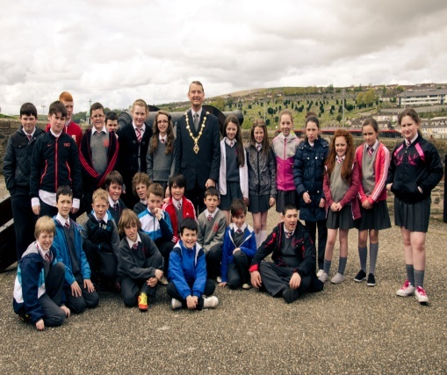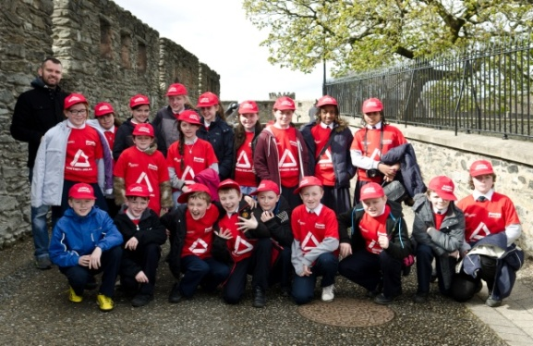
SM/NPB Comments | Project delivery is through local schools in the area providing an opportunity for children and young people to consider the impact of anti-social behaviour within their community. This project impacts on children and young people building a sense of civic responsibility and community pride and links to Social Renewal actions within the Neighbourhood Action Plan.  One of the issues affecting the Triax area is anti-social behaviour particularly at times of high tension in this interface area, as well as crime, graffiti, underage drinking etc. This project has assisted young people to address ownership for their areas through educational and environmental programmes in line with priorities in our Action Plan, such as:  - Community safety and fear of crime including anti-community activity, risk taking behaviours, sectarian clashes and nuisance behaviour.  - To improve the local environment in terms of physical environment graffiti, litter and biodiversity ie green spaces, planting, priority species.
Contact Details | Patrick Duddy – NIHE  Tel: 034489200900  E-Mail - Patrick.Duddy@NIHE.GOV.UK

Theme | Social - City-Wide Project
Project | Derry City Council - Community Safety Wardens Programme
Aim | This project is focused on responding to the individual needs of residents living in local communities by promoting community cohesion and improving the levels of cleanliness and attractiveness by reducing signal crime such as graffiti, damaged street lighting and fly tipping by reporting such matters to the relevant agencies, including Derry City Council – (enforcement of council byelaws), Department for Regional Development, the Northern Ireland Housing Executive and other Housing Agencies. The project will also focus on reducing the fear of crime and will implement crime prevention initiatives in order to reduce incidents of anti-social behaviour within each of the four Neighbourhood Renewal Areas (TRIAX, Outer West, Outer North & Waterside).
Activities | To work in partnership with other services and regeneration agencies to encourage greater community confidence, to tackle community isolation among vulnerable residents, to increase satisfaction levels with the local environment and ultimately to lower the rates of crime
Link to NR Action Plan | Waterside NR Action Plan:  - Social Renewal  Outer North NR Action Plan;  - Social Renewal  Outer West NR Action Plan:  - Social Renewal  Cityside NR Action Plan:  - Community Renewal and Social Renewal
Output | To provide an integrated/co-ordinated approach between local residents, voluntary and community sector representatives and local statutory agencies to address crime and anti social behaviour, to increase community confidence and reassurance to the move vulnerable members of the community and to create and develop a strong and confident network of community organisations which through their community safety forums will instil a sense of community pride.
Outcome | Two Community Safety Wardens in place to support each of the 4 NRA’s to reduce anti-social behaviour and fear of crime within Neighbourhoods and criminal activity black spot areas of the city.
Link to NR Strategy | Community Renewal  Community Safety and fear of crime including Anti-community activity  Increase sense of pride in how own areas look  Tackle community isolation among older and vulnerable residents  Social Renewal  Crime & Disorder  Safe Living Environment  Crime and Anti-Social Behaviour  Reduction in anti-social behaviour incidents  Physical Renewal  Safe Living Environment
Link to One Plan | Transformational Themes:  Building Better Communities
Photos | 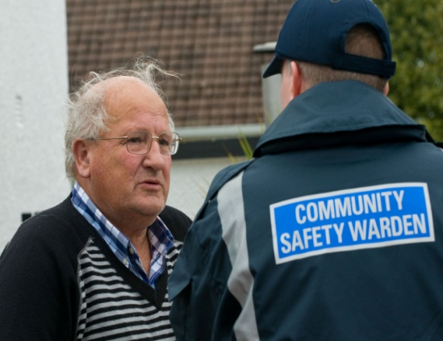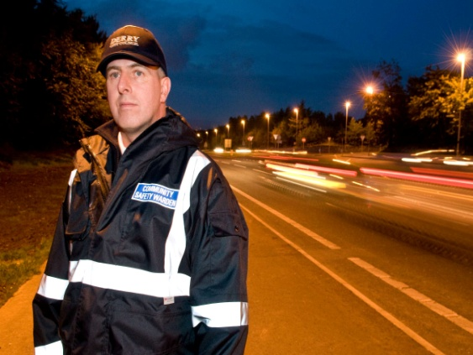
SM/NPB Comments | The project has had an impact within the local community by providing for the needs of the local communities by reducing signal crime. The Wardens presence has also acted as a deterrent by reporting crimes to the relevant authorities, as well as via encouragement increase numbers participating on the community safety initiatives. The wardens have also assisted with signposting to diversionary projects such as Youth interventions and crime support. The local wardens have also been valued in assisting to coordinate local partnership workings between residents, NRP’s an statuary agencies to address crime and anti community behaviour.  An identified need within the NAP affecting the residents in the Triax area is anti-social behaviour particularly at times of high tension in this interface area, as well as crime, graffiti, underage drinking etc. This project has assisted to address anti-social behaviour in line with priorities in our Action Plan, such as:  - Community safety and fear of crime including anti-community activity, risk taking behaviours, sectarian clashes and nuisance behaviour.
Contact Details | Dermot Harrigan – Derry City Council  Tel: 02871 365151  E-mail: Dermot.Harrigan@derrycity.gov.uk

