Theme | Economic
Project | Bloody Sunday Trust – Museum of Free Derry
Aim | The aim of the project is, through a non-profit social economy initiative, to provide a focal point for visitors to the Triax area from what was a previously derelict building into a flagship building with education and meeting facilities that will be of use to the entire community. It is a central part of the tourism product in the area and it also helps stimulate and sustain employment in related projects and local small businesses. The museum encourages reconciliation through fostering greater understanding, acknowledgment and acceptance of the different perceptions and experiences of different communities by tackling the ongoing social problems that pertain to the area such as sectarianism and trouble at interfaces by educating people about the root causes and highlighting the consequences.
Activities | Include:  Provision of a Cultural Facility  Promotion of Cultural Tourism  Promotion of Reconciliation  Delivery of Educational Programmes in Irish History and Culture  Promotion of Local Business in Triax NRA  Volunteering Opportunities
Link to NR Action Plan | Cityside NR Action Plan:  - Economic Renewal & Social Renewal  - Economic Renewal
Output | To establish a vibrant Cultural Facility through the Museum of Free Derry, focused on cultural tourism, delivery of educational programmes in Irish History and Culture and the promotion of reconciliation within the Triax NRA of Derry.
Outcome | A vibrant Cultural Facility is developing within the Triax NRA – the Museum of Free Derry is open to the public and there is an increase in the number of tourists and students accessing the facility and the educational history and cultural tours and programmes, access to artefacts and a photographic archive, reconciliation programmes, volunteering opportunities etc. The organisation has been instrumental in taking forward the Tourism Sub Group in the area in partnership with the Strategy Manager and in promoting the tourism potential within this area of need. The Museum is also just about to embark on a £2m redevelopment which will greatly enhance its capacity and create a new flagship building for the NRA and the City.
Link to NR Strategy | Community Renewal:  Increase in community capacity/capital/cohesion;  Improvement in community relations;  Increase in the percentage of residents involved in volunteering activities.  Physical Renewal:  Increased satisfaction levels with local environment;  Increase in number/quality of community facilities.
Link to One Plan | Transformational Themes:  Building Better Communities  Employment & Economy
Photos | Students Visiting Museum: Proposed New Build: 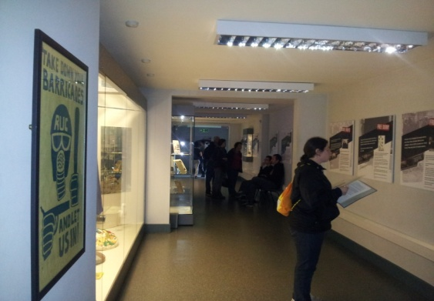 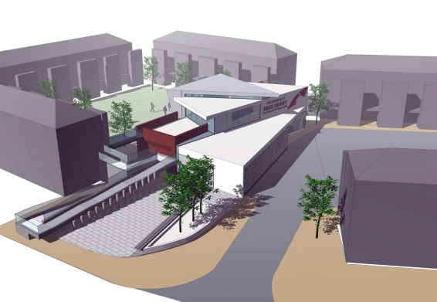
SM/NPB Comments | The Museum of Free Derry is central to development of the Community Tourism Product and Strategy in the Triax Area. The development of the new build will enhance the tourist product but it will also regenerate an area of the Bogside that has long been described as an anti-social behaviour hotspot. The Museum attracts thousands of tourists and visitors to area every year which provides economic spin offs to the area and city.  The Museum of Free Derry play a central role in the Culture and Tourism Sub-group as Adrian Kerr, Manager, currently chairs the group which has key responsibility for implementing Towards a Community Tourism Strategy for Triax and a number of actions and priorities listed within the Triax Neighbourhood Action Plan in particular:  - Lack of a co-ordinated strategy to promote heritage/cultural community tourist initiatives in the Triax area.
Contact Details | Adrian Kerr – Manager  Tel: 02871 360880  Email: Adrian@bloodysundaytrust.org

Theme | Economic - City-Wide Project
Project | Derry City Council – Active Citizenship Through Sport
Aim | This project delivers a skills building programme that will enable people from groups with few qualifications, young people, the long-term unemployed, disabled people, women and local coaches and community volunteers to take part in an integrated range of accredited training opportunities alongside non accredited training opportunities in sport and physical activity. These individuals will then be supported within their local communities to establish and/or to support new or existing sport and physical activities that enable local people to participate in a range of physical activity programmes delivered by the newly accredited coaches/ volunteers.
Activities | Include:  Training Programmes for Sporting Qualifications  On Ground Programme delivery within Neighbourhood Renewal Areas
Link to NR Action Plan | Cityside NR Action Plan:  - Community Renewal & Social Renewal  - Economic Renewal  Waterside NR Action Plan:  - Community Renewal  - Social Renewal  - Economic Renewal  Outer West NR Action Plan:  - Community Renewal  - Social Renewal  - Economic Renewal  Outer North NR Action Plan:  - Community Renewal  - Social Renewal  - Economic Renewal
Output | To deliver a project that will create an infrastructure of play and sport that is serviced and delivered by local people in their own communities which will help address issues around health, well-being, social isolation, education and skill levels in line with many of the NAP Priorities highlighted within the Action Plans across all 4 NR areas.
Outcome | Local residents trained as coaches and volunteers each year who are then engaged in delivering new or existing sport and physical activities within the 4 NRA’s enabling local participation in a range of physical activity programmes.
Link to NR Strategy | Community Renewal:  Increase in community capacity/capital/cohesion  Increase in the percentage of residents involved in volunteering acctivities  Improvement in community relations  Social Renewal:  Increase in overall life expectancy  Economic Renewal/Worklessness:  Reduction in percentage of population economically inactive
Link to One Plan | Transformational Themes:  Building Better Communities  Education & Skills  Employment & Economy  Health & Well Being
Photos | Derry City Summer Scheme: MUGA Mid Term:  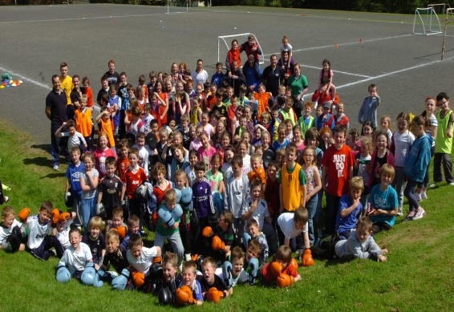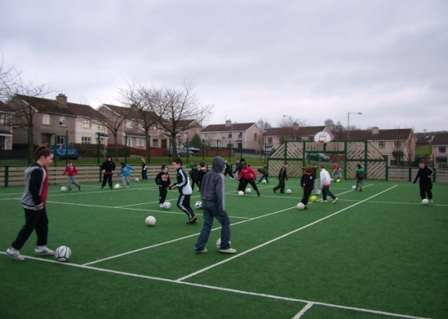
SM/NPB Comments | The Active Citizenship Through Sport Programme has provided opportunities for local people to access training in sport and physical activities allowing sporting and physical activity programmes to be delivered locally. It particularly targets groups that traditionally are not involved in sport and physical activity young women, older people and the unemployed. It has impacted positively on the Neighbourhood Action Plan linking to actions under Community Renewal, Social Renewal and Economic Renewal.  One of the issues affecting the Triax area is educational underachievement and this project targets people who have little academic qualifications and provides them with accredited training opportunities in sporting themes. The participants are then supported to utilise their training qualifications within their own communities to provide programmes for resident participation. This project has assisted priorities in our Action Plan in addressing the barriers to employment for some residents aswell as providing much needed community programmes to increase community involvement, community self-esteem etc.  The outcomes of Active Citizenship Through Sport delivers on the Triax NAP as it directly impacts on a number of identified priority needs;  - Barriers to employment, lack of skills and qualifications needed for employment has been a major issues in this community for decades.  - Community safety and fear of crime including Anti-community activity, risk taking behaviours, sectarian clashes and nuisance behaviour.  - Health Inequalities and poor health have been a fact of life in this and other working class deprived communities for decades.
Contact Details | Tommy McCallion - Derry City Council  Tel: 02871 365151  Email: Thomas.McCallion@derrycity.gov.uk

Theme | Economic - City-Wide Project
Project | Triax Ltd - Derry 2020
Aim | The project aims to:  Target those most removed from the labour market  Actively recruit cross sections of the target group through a novel community recruitment process  Provide detailed learning assessments and personalised action/training plans  Provide accredited training across all levels and practical vocational/employability courses ensuring participants are “job ready”  Develop links with employers, identifying recruitment needs and offer suitable work placements/ILM’s and realistic current labour market options
Activities | The project provides a holistic menu of engagement, advice, education, guidance, training and employment opportunities centred within local communities supported by a range of Support Organisations. The collaborative approach employs a community development approach and will incorporate a combination of activities; personal development, employability workshops, levels 0-2 courses, higher level (3+) specialised courses, practical/vocational options, job sampling, and intermediate labour market (ILM) options for those who wish to progress. It will enable people to access all available opportunities to gain the education and skills to find sustainable employment and make them inclusive in economic society.
Link to NR Action Plan | Cityside NR Action Plan:  - Economic Renewal & Social Renewal  Waterside NR Action Plan:  - Economic Renewal & Social Renewal  Outer West NR Action Plan:  - Economic Renewal & Social Renewal  Outer North NR Action Plan:  Economic Renewal & Social Renewal
Output | To employ a community development approach to up-skilling and training residents from Neighbourhood Renewal Areas incorporating a combination of activities; personal development, employability workshops, levels 0-2 courses, higher level (3+) specialised courses, practical/vocational options, job sampling, and intermediate labour market (ILM) options for participants alongside tailoring training in line with current labour market needs
Outcome | The project will enhance the employability of individual partcipants from the 4 Neighbourhood Renewal Areas by developing skills and enhancing learning which will improve access to training and employment in line with current labour market needs.
Link to NR Strategy | Community Renewal: The project aims to increase the employability and thus reduce the economic inactivity rates of residents within TRIAX, Outer North, Outer West and Waterside Neighbourhood Renewal areas in Derry.  Economic Renewal: The project aims to develop the individual’s potential by incorporating a combination of personal development, confidence-building, team-working, and practical skills through active participation in the arts, in order to boost motivation and aspiration levels of participants.  Social Renewal: The project aims to improve the prospects and social conditions for residents who live in four of the most socially and economically disadvantaged NRAs in the North West.
Link to One Plan | Transformational Themes:  Building Better Communities  Education & Skills  Employment & Economy
Photos | To insert
SM/NPB Comments | The DERRY 2020 project is fully operational in the four Neighbourhood Renewal Areas and continues to provide pre-employment support and training to local residents who are economically inactive, unemployed, living with a disability and or health condition, NEET young people and those with no or few qualifications.  Breakdown as follows for 2012/2013  Employment  - 219 people have gained employment as a result of training or assistance from the DERRY 2020 Project  Businesses assisted/ advised  - overall 115 businesses were assisted/supported by the DERRY 2020 Project e.g. ILM support, provision of information, signposting to other services etc  Training Places  - 708 training places created/ sustained throughout 2012/2013  - 548 qualifications were formally obtained within 2012/2013  The outcomes of Derry 2020 deliver on the Triax NAP as it directly impact on a number of identified needs;  - Barriers to employment, lack of skills and qualifications needed for employment has been a major issues in this community for decades.  - Lack of co-ordinated strategy to promote heritage/cultural community tourist initiatives in the Triax area.  - Help to eradicate poverty by providing welfare/ welfare-to-work, debt advice to maximise income and connect socially excluded residents to neighbourhood services.
Contact Details | Oonagh Quigg – Gasyard Centre  Tel: 02871 262812  Oonagh@triaxtaskforce.org

Theme | Social
Project | An Gaeláras – Gaeltacht Quarter
Aim | The aim of the project is to establish a vibrant Gaeltacht Quarter, focused on economic regeneration, cultural tourism, environmental awareness and healthy living with the Cityside Neighbourhood Renewal Area and in particular within the Bogside and Brandywell area of Derry. The Gaeltacht Quarter project will promote this geographical area rich in Irish language and cultural activities by promoting Irish language, festivals showcasing performance arts, fine art, craftworks, poetry, traditional, contemporary and ethnic-diverse music alongside cultural heritage tours and awareness exercises. Local business will be advised in relation to signage, translation, and cultural and promotional opportunities etc in the run up to the City of Culture and opportunities through the Fleadh Cheoil na hÉireann in 2013, the Pan-Celtic Festival in 2014 and 2015.
Activities | Include:  Provision of a Cultural Facility  Cultural Tourism  Promotion of Irish Language and Culture  Economic Regeneration - Attracting Irish Events and Festivals to City –  Advice Provision re: signage, translation, and cultural/promotional opportunities  Delivery of Irish and Cultural Programmes  Delivery of Environmental Awareness & Healthy Living Programmes
Link to NR Action Plan | Cityside NR Action Plan:  - Economic & Social Renewal  - Community Renewal & Physical Renewal  - Community Renewal & Social Renewal  - Economic Renewal  - Social Renewal & physical Renewal
Output | To establish a vibrant Gaeltacht Quarter, focused on economic regeneration, cultural tourism, environmental awareness and healthy living within the Derry City Council area and in particular within the Bogside and Brandywell area of Derry.
Outcome | A vibrant Gaeltact Quarter is developing within the City – Cultúrlann Uí Chanáin is open to the public and there is an increase in the number of local residents, community organisations, schools, businesses and tourists accessing the facility and the various Irish language and cultural activities and environmental and health awareness programmes based there. An Gaeláras have been successful in working in partnership with Comhaltas Ceoltóirí Éireann to attract the Fleadh Cheoil na hÉireann to the City for 2013 and have assisted both statutory bodies, businesses and community groups with bilingual and other signage to promote many initiatives in the run up to the City of Culture 2013 year.
Link to NR Strategy | Community Renewal:  Increase in community capacity  Increase in the percentage of residents involved in volunteering activities  Improvement in community relations  Social Renewal:  Health – Increase in overall life expectancy  Crime & Anti-Social Behaviour – Reduction in anti-social behaviour incidents  Physical Renewal:  Increased satisfaction levels with local environment
Link to One Plan | Transformational Themes:  Building Better Communities  Education & Skills  Employment & Economy  Health & Well Being
Photos | Irish Cultural Class – Bee Keeping: Irish Signage – Tourist Board:  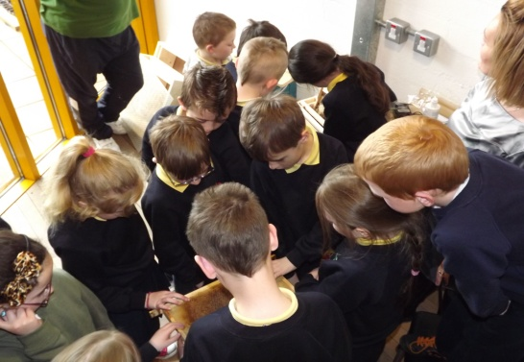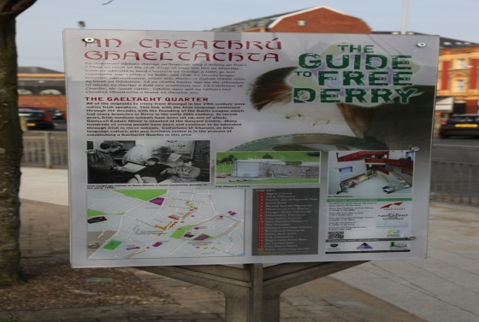
SM/NPB Comments | The development of a Gaeltacht Quarter is a key priority for Triax and has been identified in Towards a Community Tourism Strategy for Triax. The implementation of this strategy is vital to the social, economic and cultural development of this area and is a priority within the Traix Neighbourhood Action Plan ie:  - Lack of a co-ordinated strategy to promote heritage/cultural community tourist initiatives in the Triax area.  An Culturlann play a vital role in the Triax Culture and Tourism Sub-group and engage with the wider community, business and education sectors to advise on opportunities for bi-lingual signs and policies. The promotion of the Irish Language and Culture has benefits for local residents economically, socially and culturally. Culturlann are central to much of the cross community and peace building work that takes place in the Triax Area.
Contact Details | Donncha MacNiallais – Project Development Officer  Tel: 02871 264132  Email: donncha@culturlann-doire.ie

